

Claimant Overview and Representation Requests Permissions Release to Accredited Representative Portal
Version 4
Launch: April 2026

Revision History
Date | Version | Description | Author
9/2025 | 001 | Public release of the Accredited Representative Portal | Benefits Portfolio/Accredited Representative Facing team
11/2025 | 002 | Adding the ID.me sign-in method | Benefits Portfolio/Accredited Representative Facing team
1/2026 | 003 | Adding submission of VA Form 21-0966 (Intent to File a Claim for Compensation and/or Pension, or Survivors Pension and/or DIC) | Benefits Portfolio/Accredited Representative Crew
4/2026 | 004 | Adding release of Claimant Overview  Adding new permission type for Representation Requests | Benefits Portfolio/Accredited Representative Crew

Table of Contents
Overview
User Access
Navigation
Functionality
1. Home page and help
2. Signing in to the portal
Setting up a portal account
Step 1: Identify the email on file with OGC
Step 2: Create a Login.gov or ID.me account
Step 3: Associate the OGC email with the account
Step 4: Sign in to the portal
3. Dashboard
Authorized Dashboard
Find claimants you represent
Review representation requests
Submit forms
Unauthorized dashboard
4. Find claimant
Search results
5. Representation requests
Representation request cards
Representation request details page
Claimant information
Authorization information
Accepting or declining a request
Turning on the feature
6. Submissions
VA Form 21-0966
Introduction page
Step 1: Claimant background
Step 2a: Claimant information
Step 2b: Claimant and Veteran information
System will verify representation and check for intent to file
Step 3: Review and submit
Confirmation
VA Form 21-526ez
Introduction page
Step 1: Claimant information
Step 2: Upload files
Uploading VA Form 21-526ez (required)
Upload supporting evidence (optional)
Step 3: Review and submit
Confirmation
VA Form 21-686c
Introduction page
Step 1: Claimant background
Step 2a: Claimant information
Step 2b: Claimant and Veteran information
Step 3: Upload files
Uploading VA form 21-686c (required)
Upload supporting evidence (optional)
Step 4: Review and submit
Confirmation
Major Issues and Error Messages
User access issues
Login.gov issues
ID.me issues
Accreditation not found
Troubleshooting unverified accreditation
Additional user access troubleshooting
Representation request issues
Request failed to process
Resolving a failed request
Submission Issues
Upload errors
Losing unsaved work
The form can’t be submitted
Submission failed to process

Overview
The Accredited Representative Portal is a secure online tool that enables accredited representatives to efficiently establish representation and manage their work in supporting Veterans through the benefits claims process. With its user-friendly interface and streamlined processes, the portal is designed to save you time and effort.

User Access
Access to the portal features is contingent upon having a Login.gov or ID.me account. Additionally, users must hold an accredited VSO representative, attorney, or claims agent status to gain full access to the portal features.

When a user signs in to the portal using a Login.gov or ID.me account, the portal will verify whether the user has an active accreditation in OGC’s database.

- If there is an active OGC accreditation, the user is “authorized,” and access to portal features will be granted.
- If there is no active OGC accreditation, the user is “unauthorized,” and access to portal features will be restricted.

Navigation
The Accredited Representative Portal is accessed by navigating to https://www.va.gov/representative.

Functionality

1. Home page and help
The unauthenticated home page provides key information for users, including:

- An overview of the portal’s main features
- Guidance on how to get started and set up an account
- Contact information for VSO managers interested in using the Representation Requests feature for their organization
- Instructions on how to sign up for product feedback sessions
- Resources on how to apply for accreditation
- A section for Veterans seeking assistance with a claim, directing them to the appropriate resources

Help can be accessed in the upper right corner of the home page, next to the Sign in button. The Help section offers a more comprehensive and detailed overview of the portal and its usage: https://www.va.gov/representative/help.
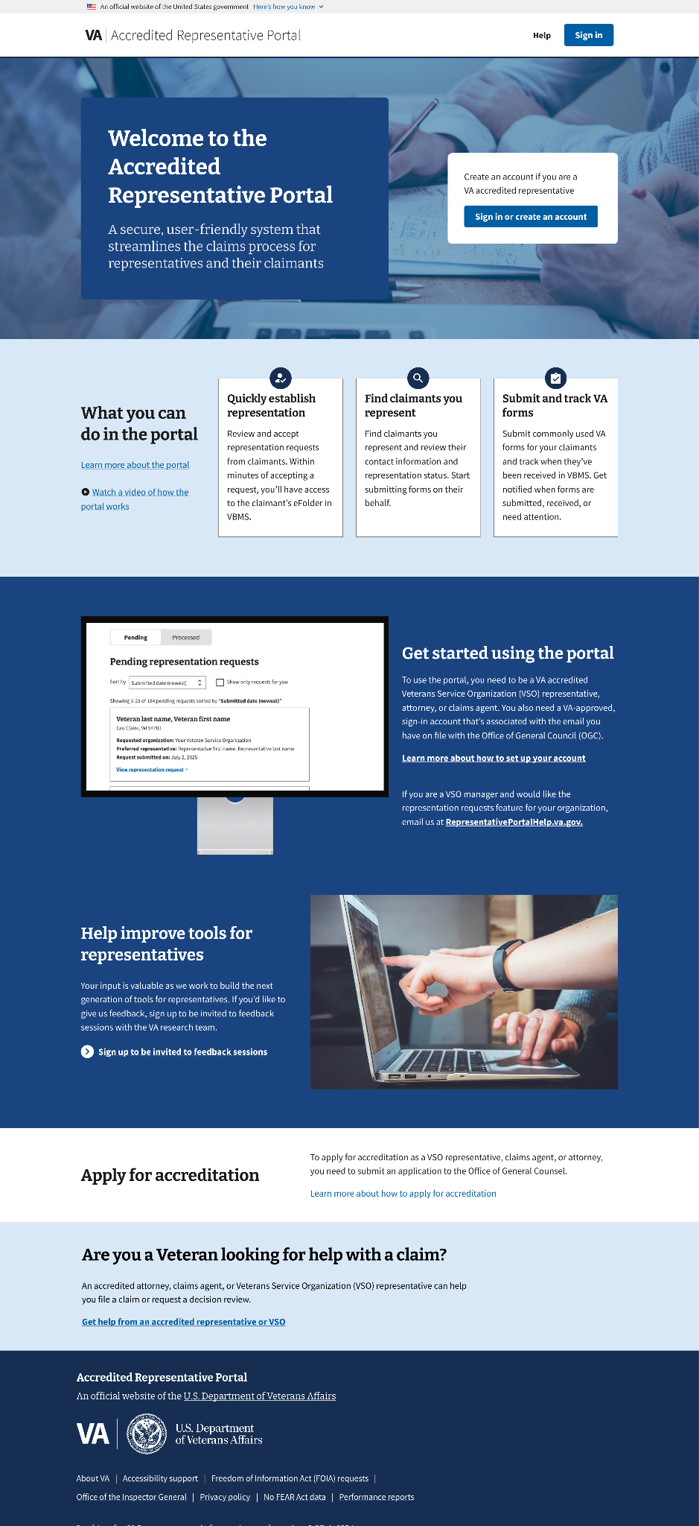

2. Signing in to the portal
To sign in and gain access to the portal features, representatives must:
- Have a Login.gov or ID.me account
- Associate their account with the email they have on file with the VA’s Office of General Counsel (OGC)

Setting up a portal account

Step 1: Identify the email on file with OGC
Representatives can find out what email they have on file with OGC by looking themselves up using VA.gov’s Find a Representative tool, which is designed to help representatives locate their information in the OGC database.
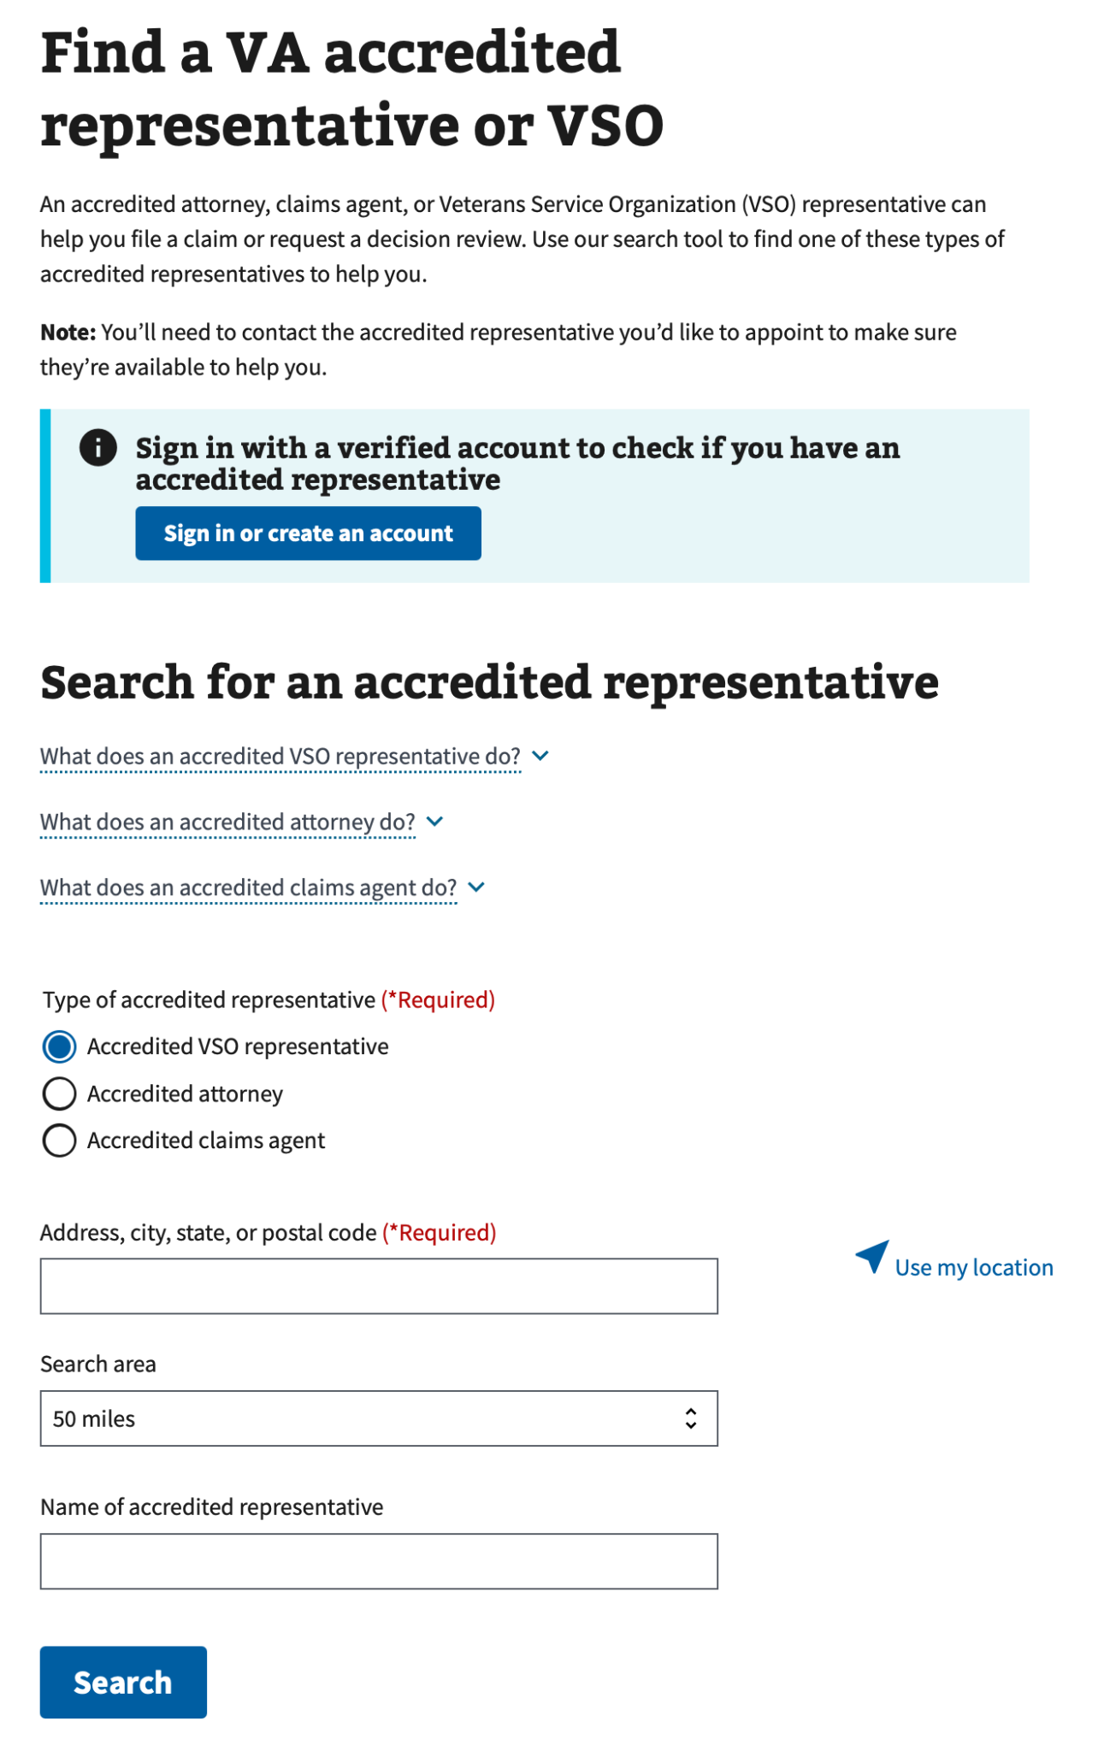

If they cannot find their name using the Find a Representative tool, they can try using the OGC accreditation search tool.
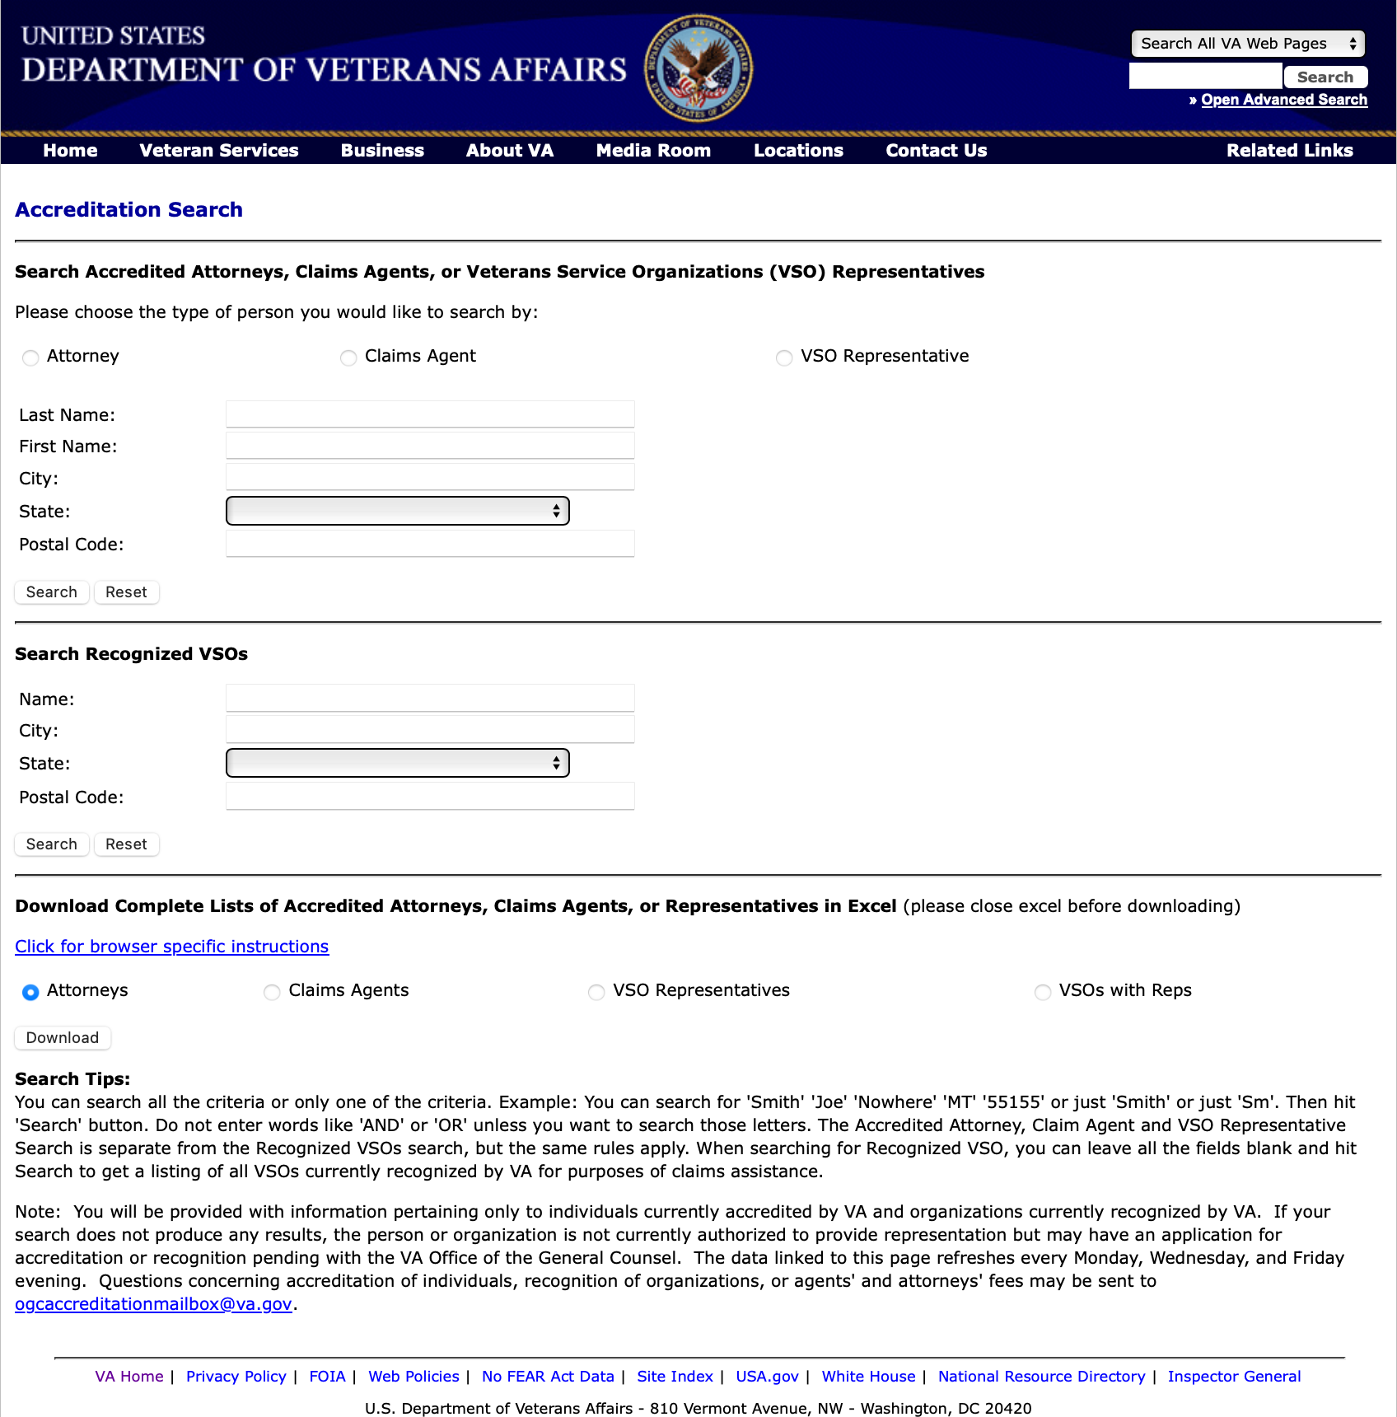

Note: If their record appears in the OGC accreditation search tool but not in the Find a Representative tool, it likely means the VA does not have a valid physical address on file for the representative.

Step 2: Create a Login.gov or ID.me account
Login.gov and ID.me are services that provide secure ways to sign in to many government websites using just one account. We recommend that representatives create their account using a personal email they’ll always have access to.

Representatives should follow the service provider's instructions to create their account:

- Learn how to create your Login.gov account
- Learn how to create your ID.me account

Note: If the representative already has a Login.gov or ID.me account they use for another site, they can use that same account for the portal. They do not have to create a new account.

Step 3: Associate the OGC email with the account
If the representative created their Login.gov or ID.me account using a personal email, they’ll need to add the email address they have on file with OGC to their account.

Representatives should follow the service provider’s instructions to add an email to their account:

- Learn how to add an email to your Login.gov account
- Learn how to add an email to your ID.me account

Step 4: Sign in to the portal
There are two sign-in buttons on the unauthenticated home page of the portal. Representatives can click either of these buttons to start the sign-in process.

If a representative is signed in to VA.gov and then signs in to the Accredited Representative Portal, they will be logged out of their VA.gov Veteran account. The benefits they receive as a Veteran won’t be affected when they use this portal. VA.gov uses their Veteran profile, while the portal uses a separate representative profile. There is no co-mingling of information between the two systems.
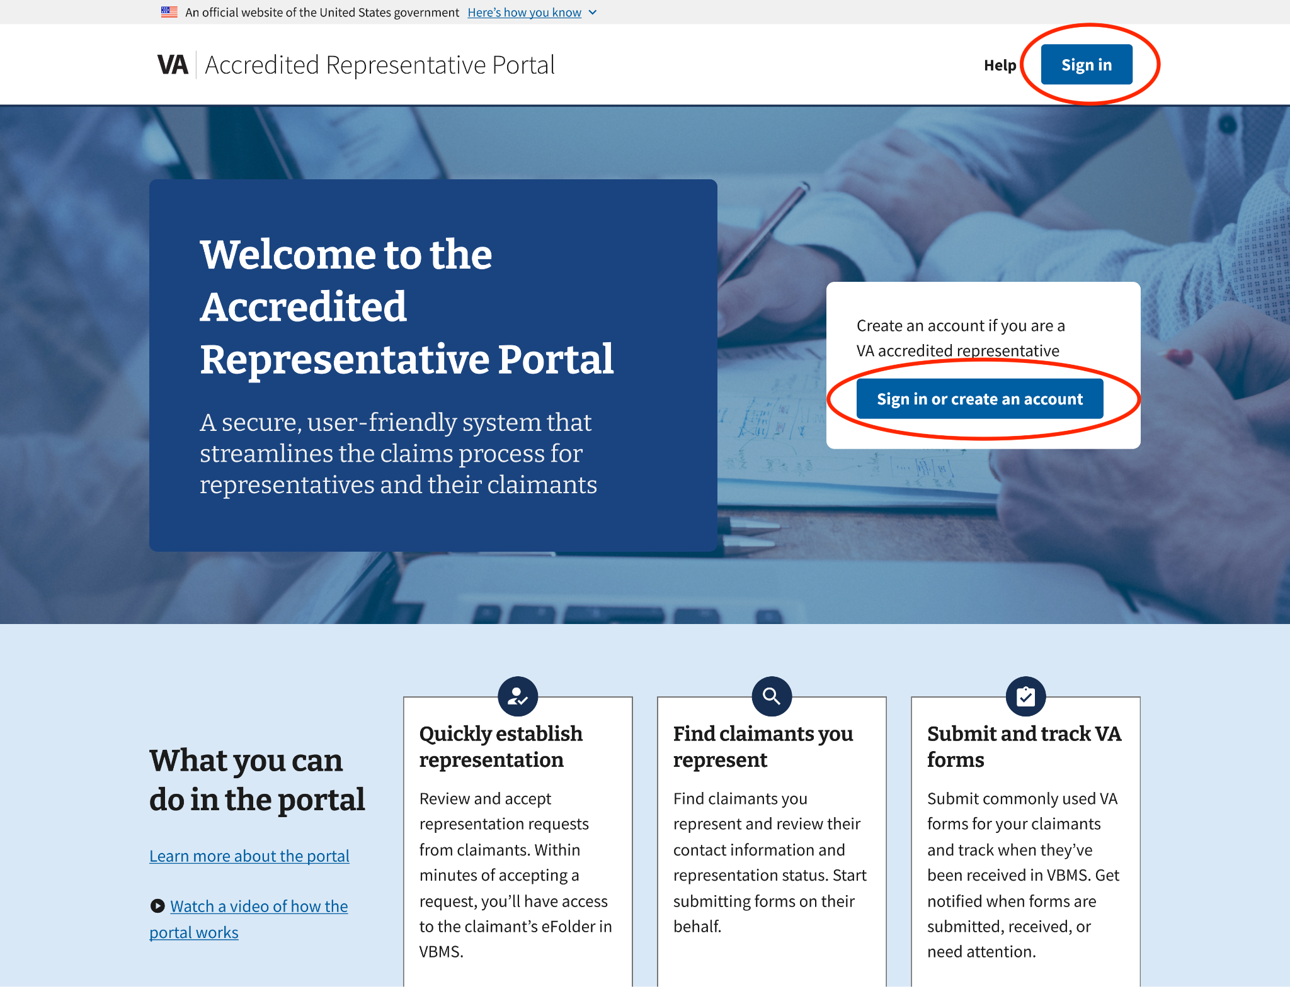
When the user clicks one of the sign-in buttons, they’ll be prompted to sign in using their Login.gov or ID.me account. They’ll be guided through the sign-in process, and once completed, they will be signed in to the portal.

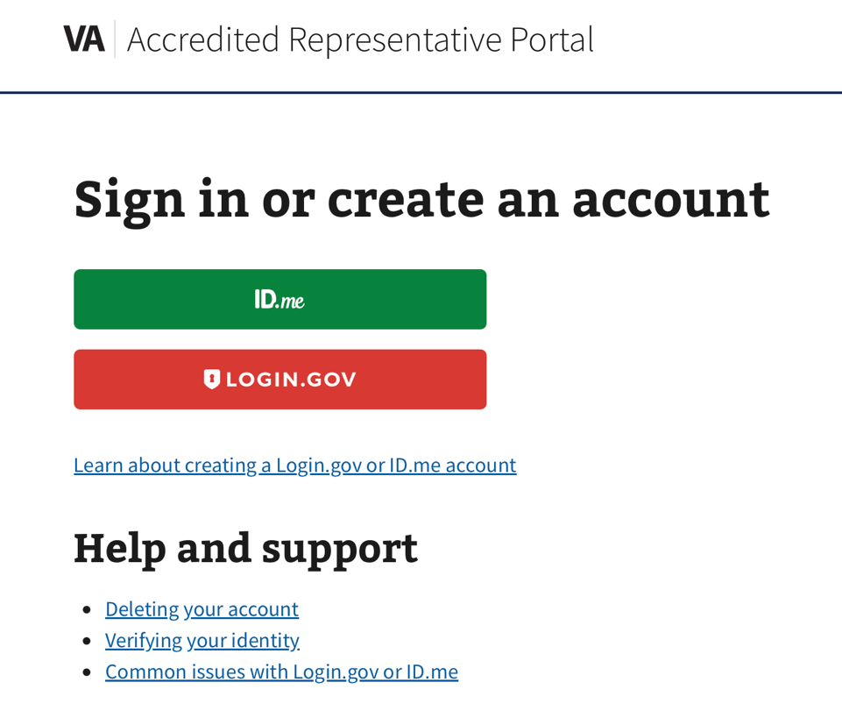
Optional: Adding PIV card sign-in
Representatives can use a PIV card to sign in to the portal if they add it to their Login.gov account (this option is not available with ID.me). While signed in to Login.gov, navigate to Your Account > Your Authentication Methods > Add Your Government Employee ID.
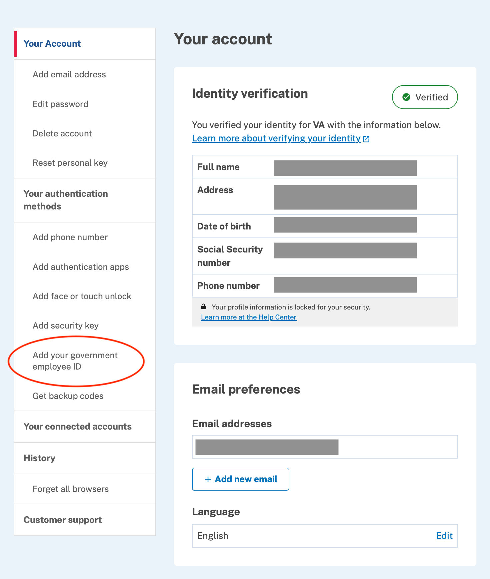

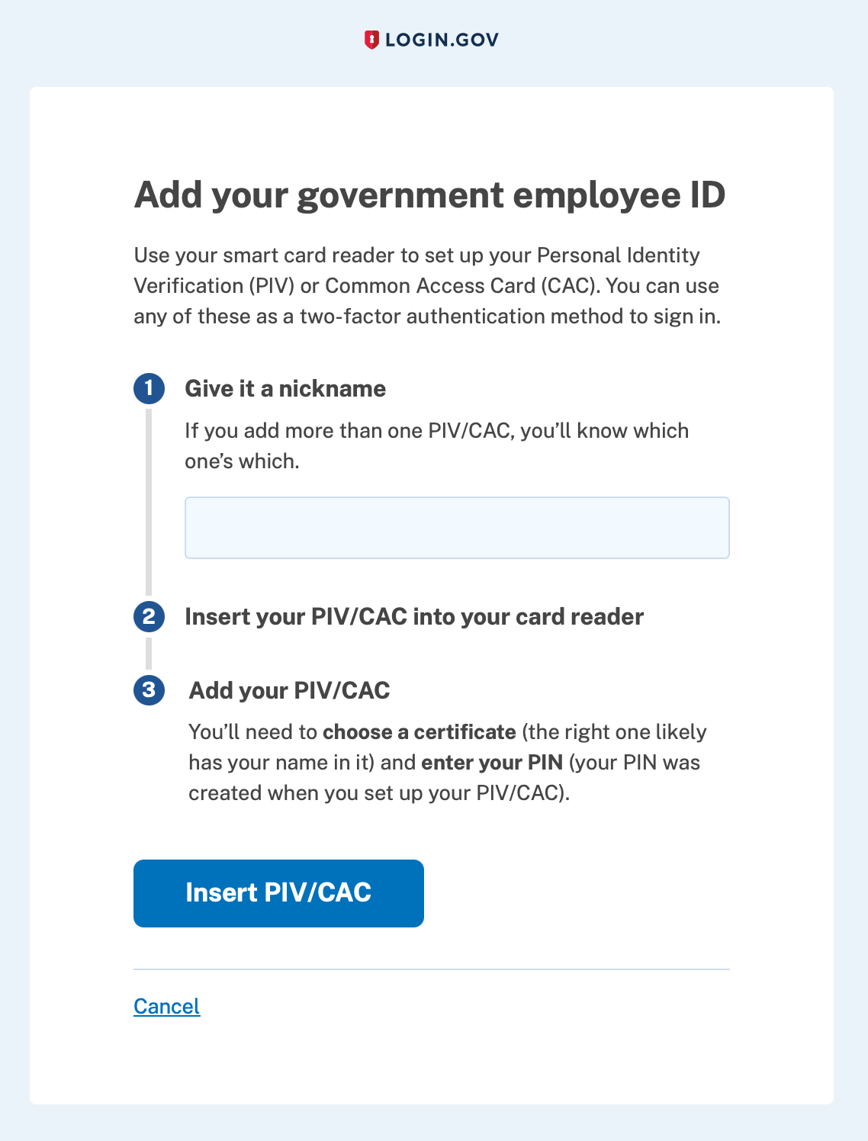
The representative will be prompted through steps to add their PIV card.

Once the representative successfully adds their PIV card to their Login.gov account, they’ll be able to use this method to sign in to the portal. The PIV card must be plugged into their computer when signing in. Representatives should select the Sign in with your government ID option at the bottom of the sign-in page and follow the prompts to complete their sign-in.

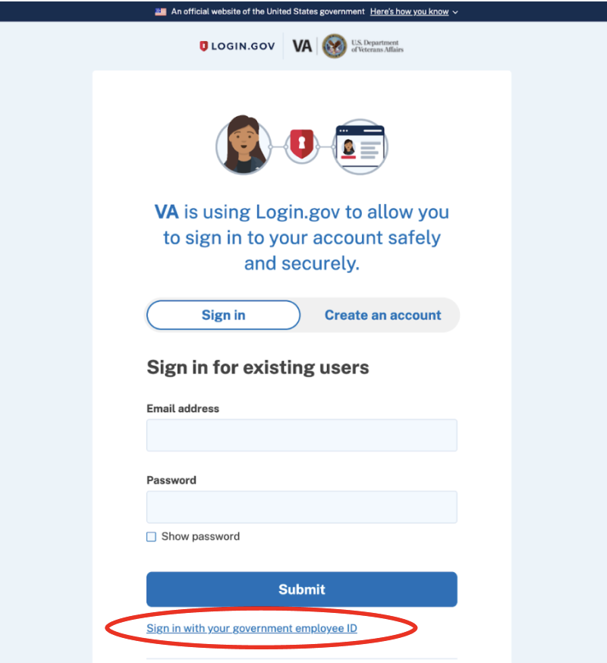
3. Dashboard
Note: This feature is available to all users, but the content will vary depending on whether the user is authorized or not.

Authorized Dashboard
When a user signs in to the portal and their current accreditation is verified, they will be directed to an authorized dashboard. The dashboard displays three call-to-action cards that link to the key features of the portal that accredited representatives have access to:

- Find claimants you represent
- Review representation requests
- Submit forms
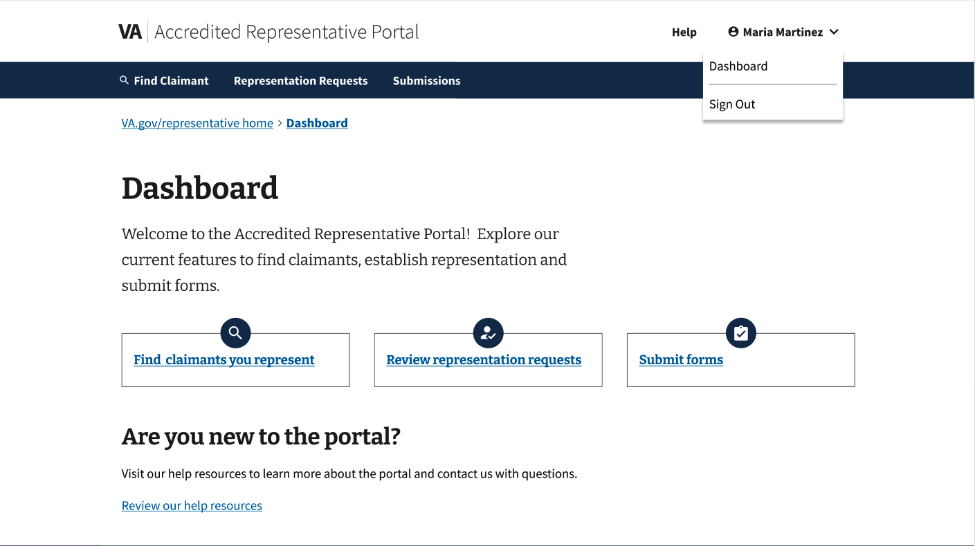

Find claimants you represent
This card enables representatives to access the Find Claimant page, where they can search for and view claimants for whom they are authorized to assist. This card corresponds to the “Find Claimant” button located in the top navigation bar.
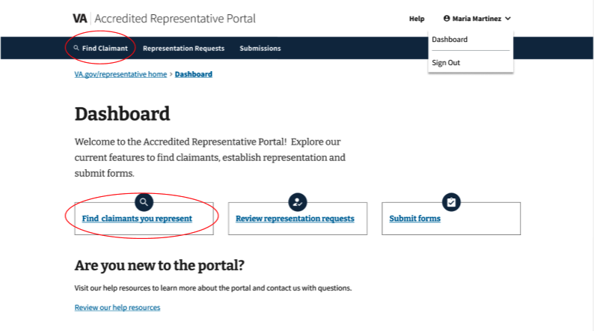

Review representation requests
This card provides access to incoming representation requests from Veterans or claimants.
It corresponds with the Representation Requests button in the top navigation bar.
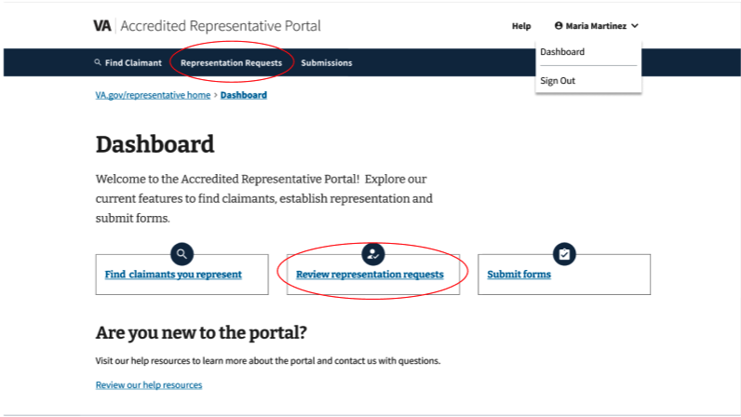

Submit forms
This card provides navigation to Submissions, where representatives can submit forms on behalf of their claimants and view a recent history of the forms they have submitted. It corresponds with the Submissions button in the top navigation bar.
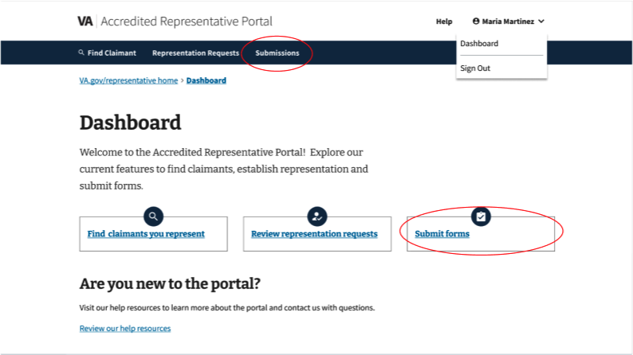

Unauthorized dashboard
When a user signs in to the portal and the current accreditation cannot be verified, they will be taken to an unauthorized dashboard. The dashboard displays an alert letting them know their accreditation couldn’t be verified. There are also links to help troubleshoot login issues and learn about the accreditation application process.

If the user attempts to navigate to any part of the portal or any other page to which they do not have access, the system will redirect them back to this unauthorized dashboard.
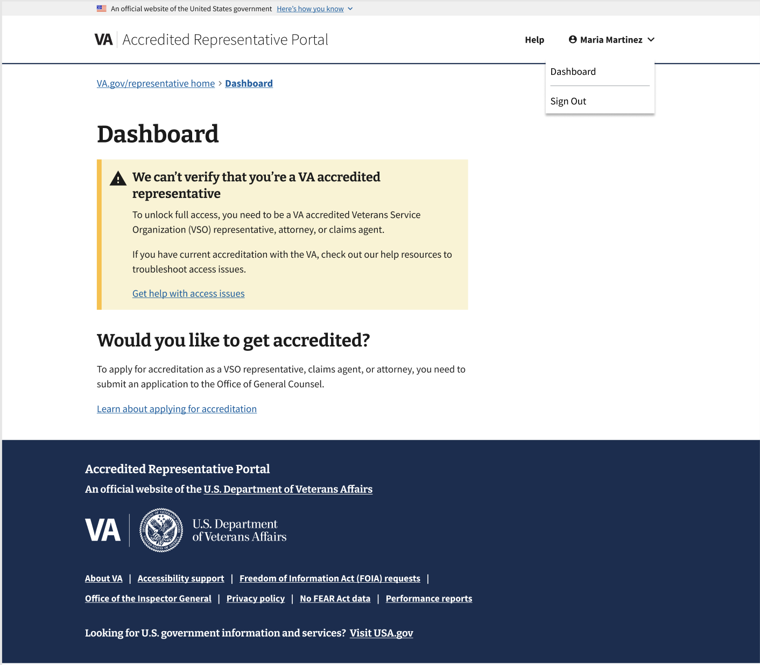

4. Find claimant
Note: This feature is available to all authorized users.

The Find Claimant feature can be accessed by clicking the Find Claimant button in the top navigation bar or by navigating from the dashboard.
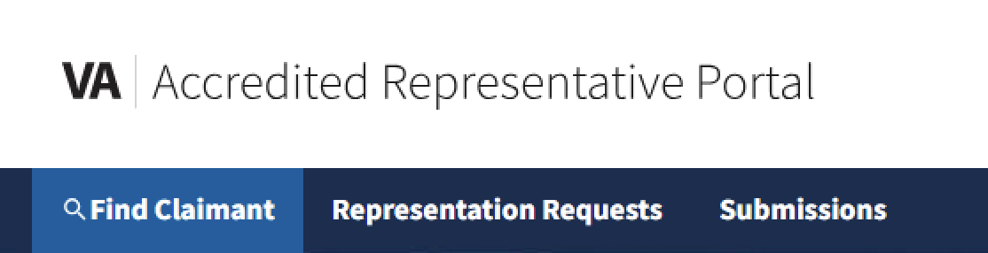

On the Find Claimant page, there are four required fields: First name, Last name, Date of birth, Social Security number. Once the required fields are filled out, the representative can initiate the search to find matching claimant records.

Note: The portal doesn’t check for limited representation, which means the representation is only for a specific claim or claims.

Search results
If the representative currently represents the claimant, the search results will show a link to go to the claimant overview where the representative can review the claimant's information.

If there is a pending representation request from the claimant, the search results will show a link to review the pending request. Typically the pending request is coming from a claimant the representative doesn’t currently represent.

Occasionally the pending request comes from a claimant they do currently represent, but the claimant wants to switch representation to a different organization the representative is accredited with. In this case, the search results will show a link to the pending request and also a link to the claimant overview.

If the representative doesn’t represent the claimant, and there’s no pending representation request, the search results will show that they don’t represent them. There will be a link to the Help page to learn more about establishing representation.

Claimant overview
To access the claimant overview, the representative uses Find Claimant (section above) to find a claimant they represent. The search results will show a link to the claimant overview.

Here’s information about the claimant that’s available in the claimant overview:
- Social Security number, date of birth, address, phone number, and email
- Current representative
- Intent to file (ITF) benefit type and date
- History of submissions sent through the portal in the past 60 days

Claimant overview section:
Submission history section, within the Claimant overview:

If the representative ever stops representing this claimant, they’ll lose access that claimant’s overview.

5. Representation requests
Note: This feature is available to authorized users accredited by one or more Veteran Service Organizations (VSOs) that have signed up to use online Representation Requests.

The Representation Requests feature can be accessed by clicking the Representation Requests button in the top navigation bar or by navigating from the dashboard.
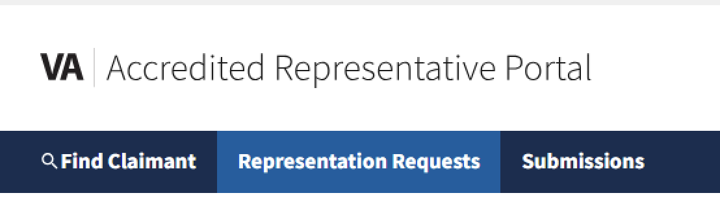
The portal currently manages requests from Veterans to appoint a VSO to represent them. For requests to be received in the portal, the Veteran needs to submit the online VA Form 21-22 on VA.gov. The VSO may elect to allow any representative they accredit to review all pending requests, or they can restrict permission to the preferred rep named in Field 16A of VA Form 21-22. Because Power of Attorney (POA) is held by the VSO, not the individual rep, accepted requests can always be viewed by any rep accredited by that VSO.

Requests can be viewed in a list of Pending (default view) or Processed by switching between tabs.

- Pending: Requests that are waiting to be accepted or declined
- Processed: Requests that have been successfully accepted or declined

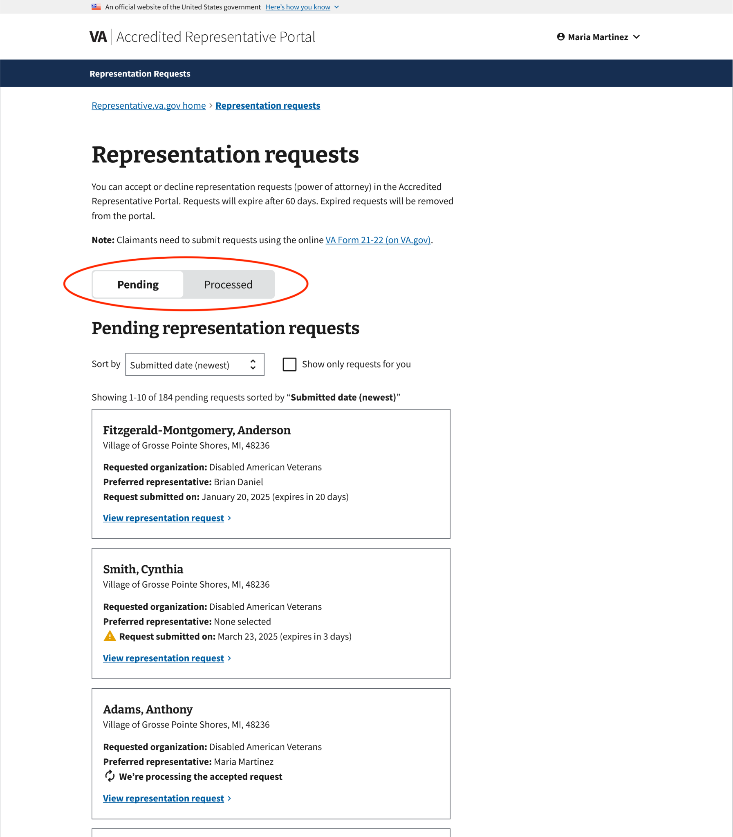
Note: If a Veteran submits a new online VA Form 21-22 while a pending request is in the portal, the newly submitted online request will replace the existing request awaiting processing.
Requests can be sorted by submission date, with the newest submissions first or the oldest submissions first.

Requests can also be filtered to show only requests for you. Selecting this checkbox will filter the list to show only requests where the signed-in portal user matches the preferred representative (named in Field 16A) on the request.
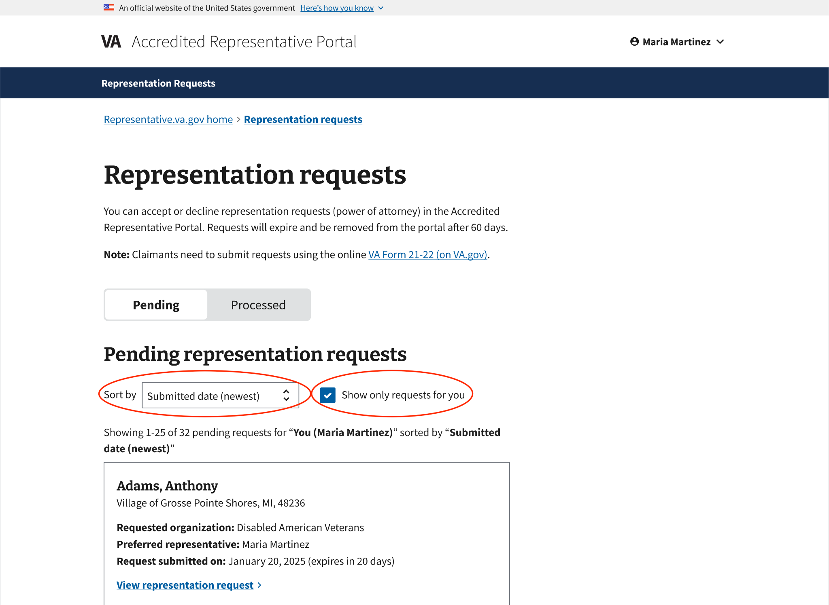

Representation request cards
The portal displays representation requests as a list of cards. Each card contains critical information from the request, including:

- Claimant name
- Claimant location
- Requested organization
- Preferred representative (if specified)
- Date the request was submitted

The ability to view more details about a specific request, and accept or decline that request, is determined by the VSO’s preferred permission level – the card is visible to all representatives at the requested org, but only representatives with permission to accept or decline the request can click the View representation request link on the card.

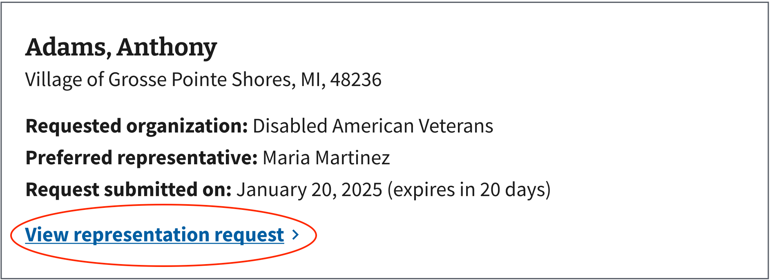
When a representative clicks on the "View representation request" link, they will be taken to the "Representation request details" page, which provides more complete details about the request.

Representation request details page
The request details page includes the same critical information displayed on the request card, as well as additional details for the Claimant and Authorization. At the bottom of the request details page is a form for representatives to accept or decline the request.
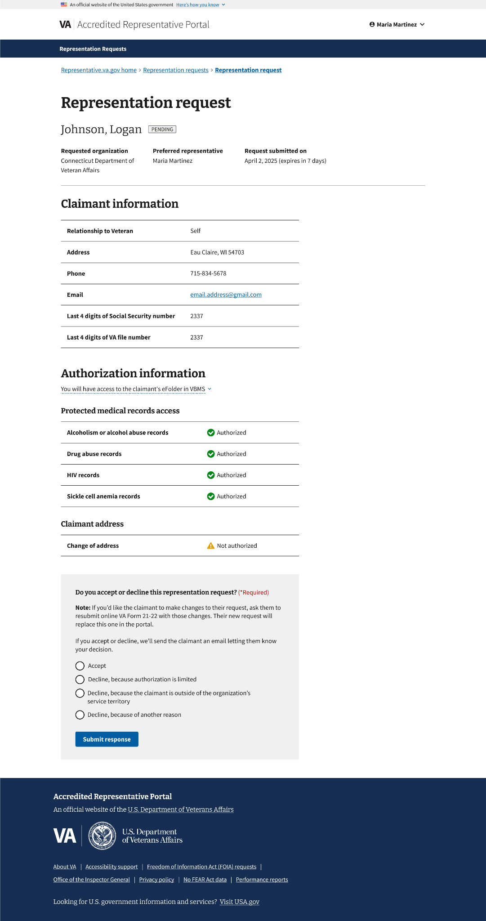

Claimant information
This section displays personal information provided by the claimant when submitting online VA Form 21-22.
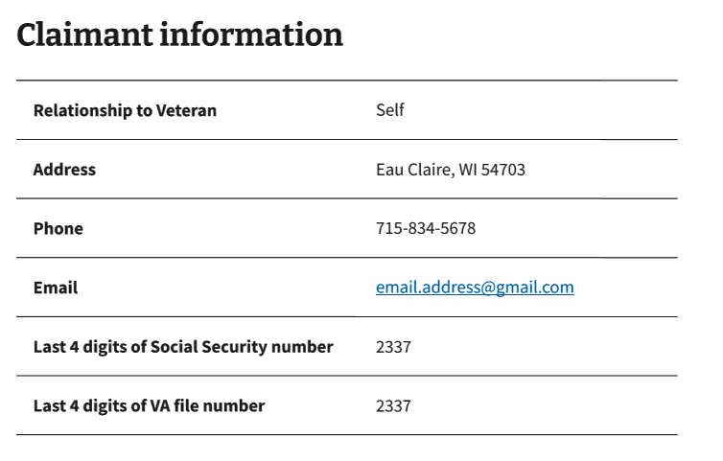

Authorization information
This section displays the authorization selections made by the claimant when submitting online VA Form 21-22. It also explains whether the representative will have access to the claimant's eFolder in VBMS, based on the authorization selections made.
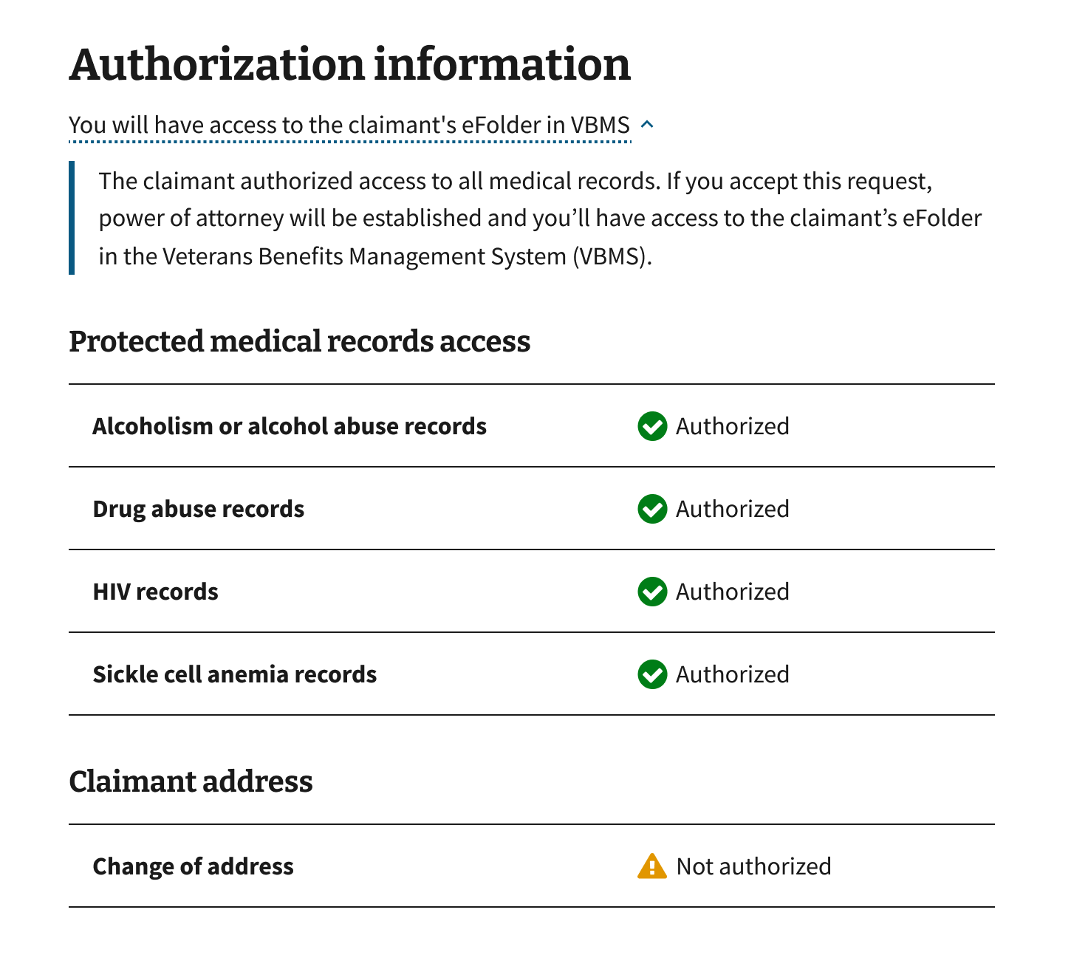

Accepting or declining a request
Once the representative has reviewed the request details page, they can use the form at the bottom of the page to either accept the request or decline it, providing a reason for the declination.
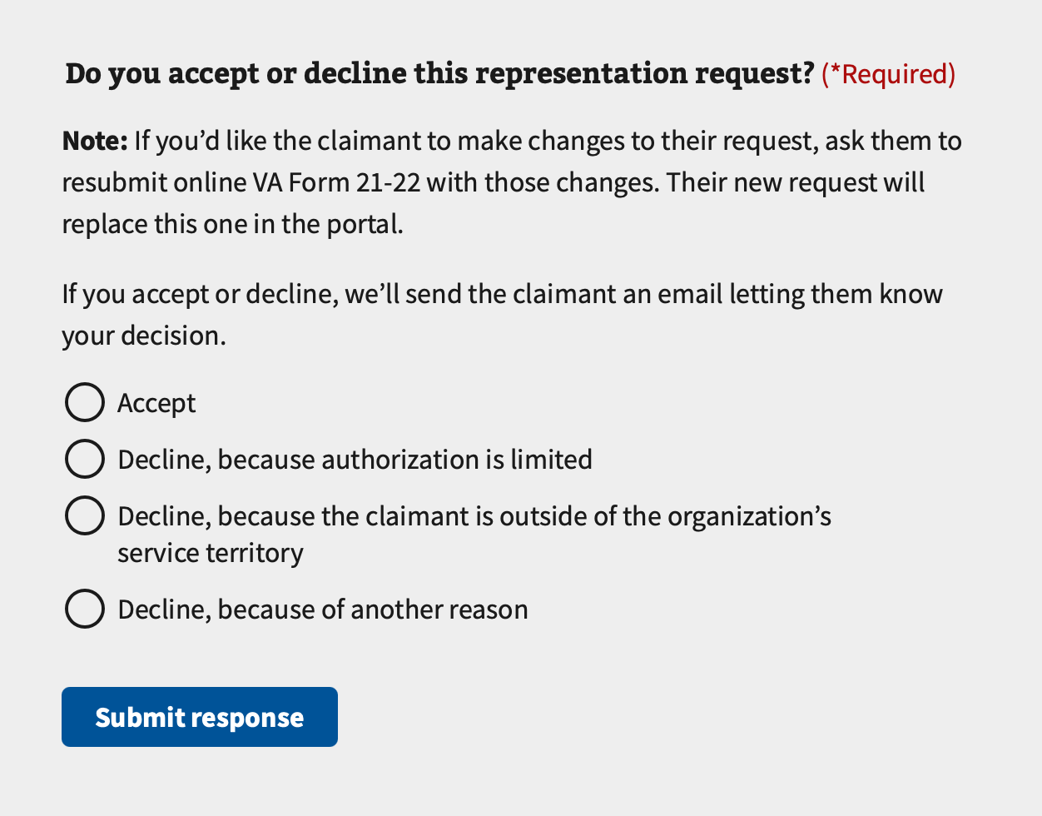
If the representative accepts the request, the page will display an alert and a status tag indicating that the request is being processed. Requests typically process within 1-2 minutes, and the representative can refresh the page to check for status updates.

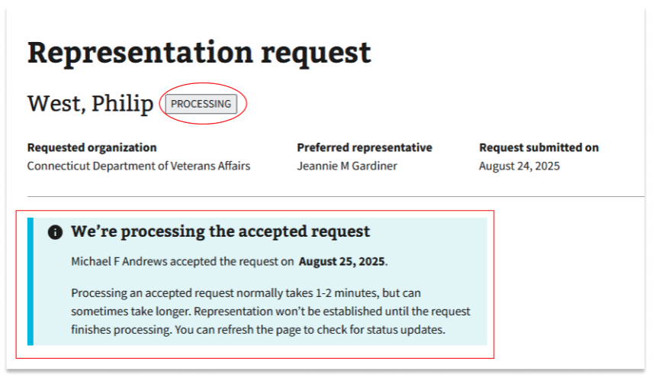
A fully processed accepted request will have an 'ACCEPTED' status and Response details about who received the request and on what date.
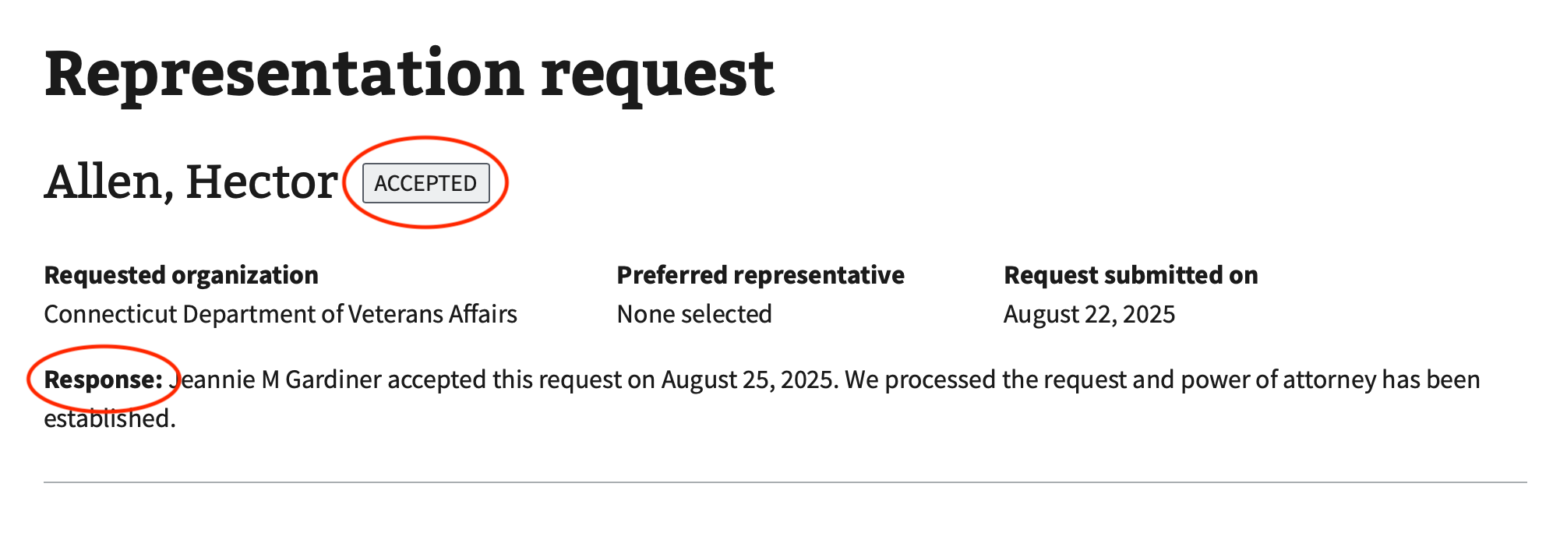
A fully processed declined request will have a “DECLINED” status, along with response details about who refused the request, the date, and the reason.

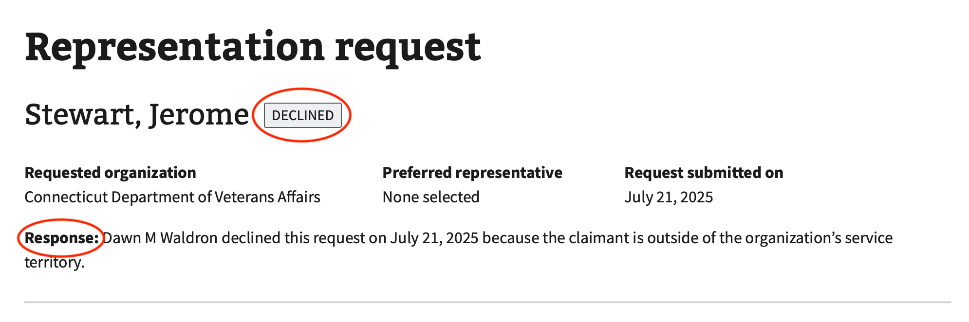

Turning on the feature
VSOs must sign up to use the Representation Request feature before it becomes available to their representatives in the portal. The VSO may elect to allow any representative they accredit to review (and accept or decline) all pending requests, or they can restrict permission for each request to the preferred rep named in Field 16A of VA Form 21-22.

If a representative with no participating VSO selects Representation Requests from the menu, an alert will be displayed indicating the feature hasn’t been activated. The alert will also provide an email address that their VSO manager can use to express interest in using the Representation Request feature.

6. Submissions
Note: The Submissions feature is available to all authorized users.

The Submissions feature can be accessed by clicking the Submissions button in the top navigation bar or by navigating from the dashboard.



VA Form 21-0966

From the Submissions page, the representative can click on Submit online VA Form 21-0966.

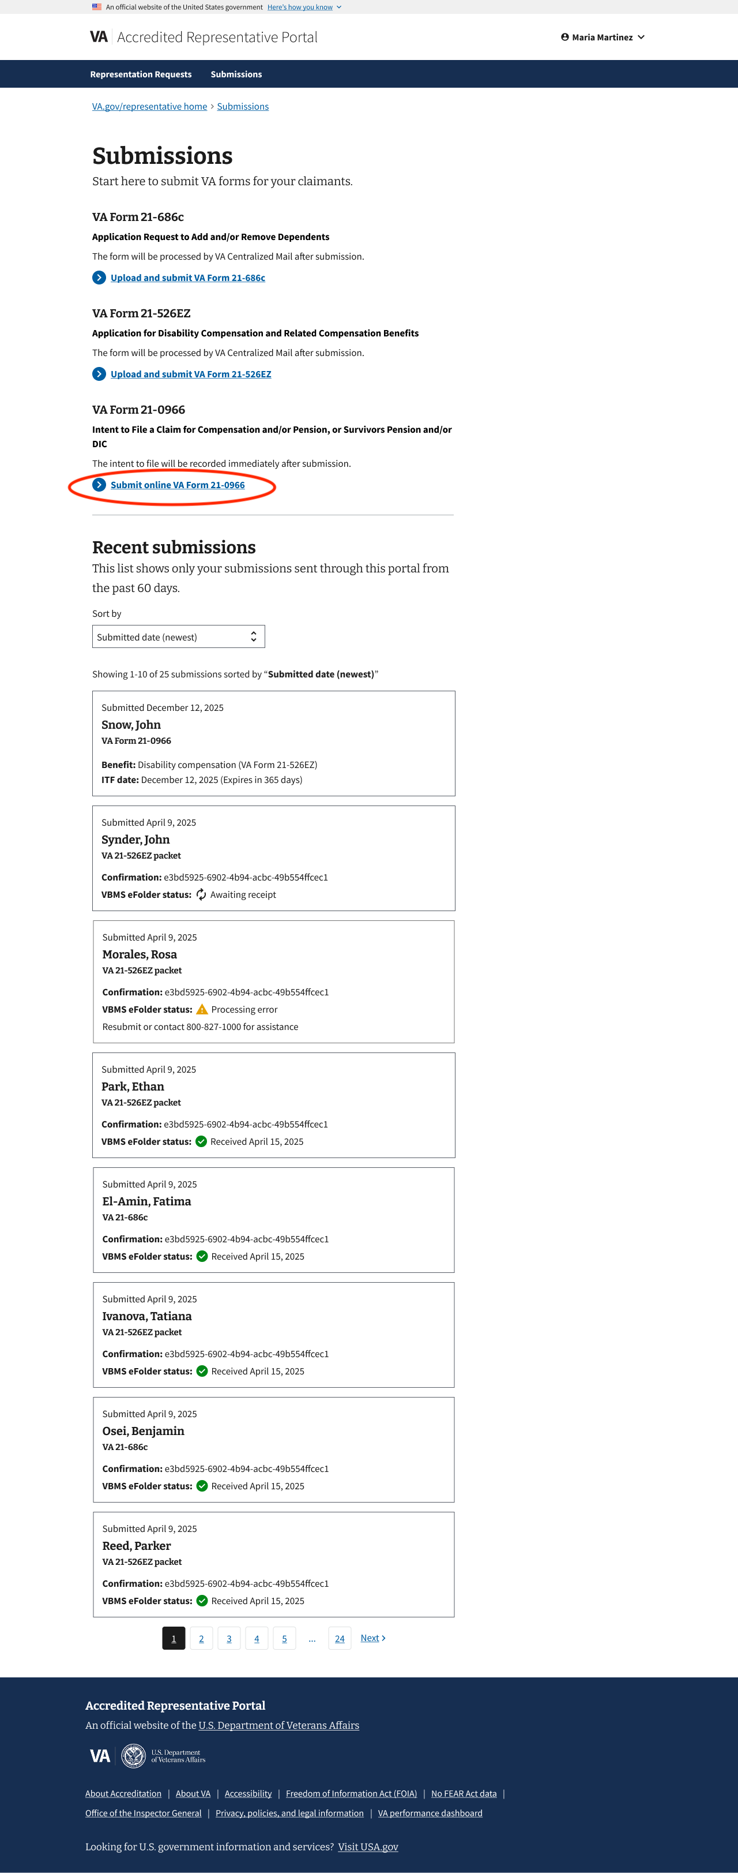

Introduction page
The VA Form 21-0966 introduction page provides instructions on how to successfully submit the form.

To initiate the process, the representative can click Start the submission.

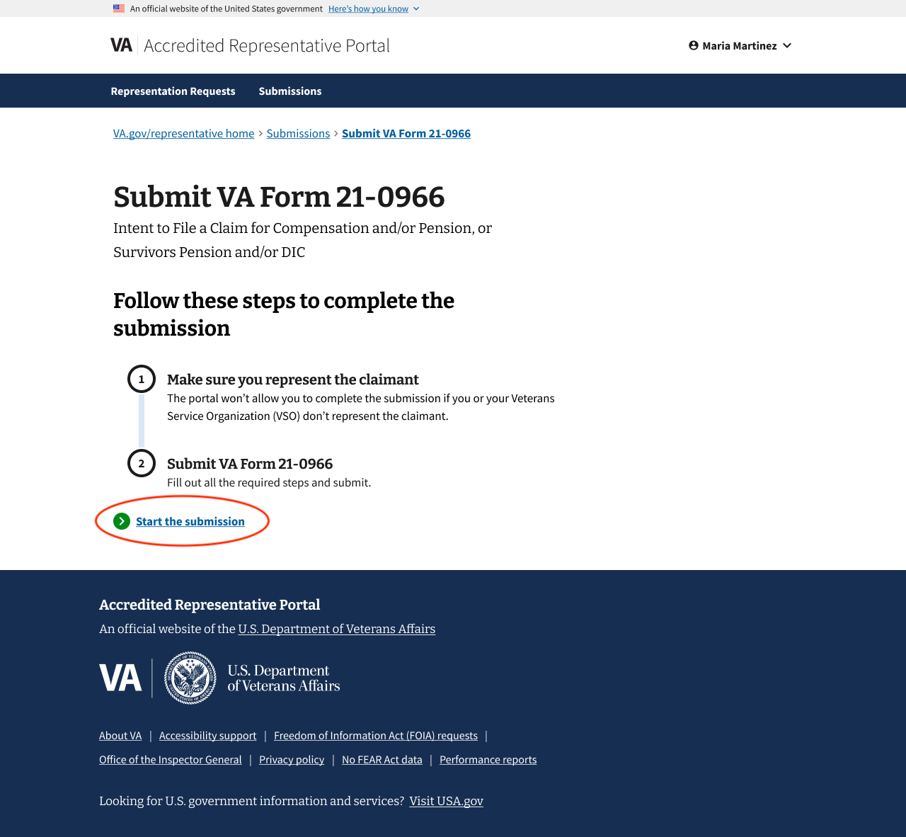

Step 1: Claimant background
This representative must select if the claimant is the Veteran, or the survivor or dependent of the Veteran. This information is required to continue.

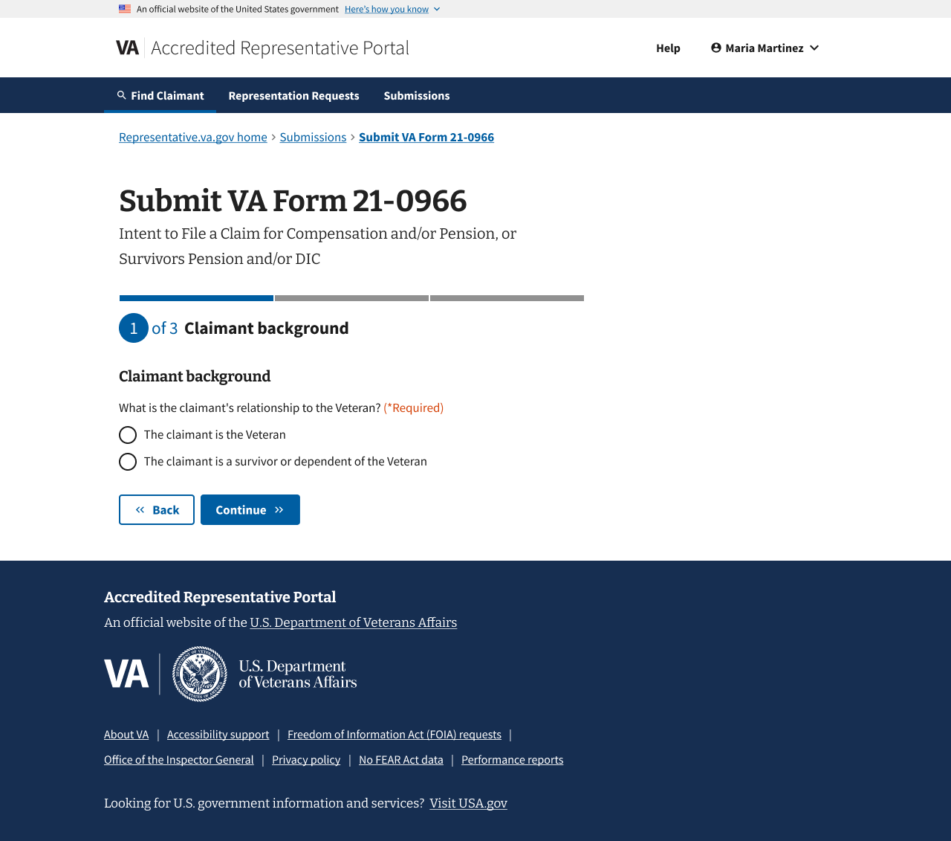

Step 2a: Claimant information
If the representative selected “The claimant is the Veteran” on the previous page, they will need to enter the Veteran's information on this page. They’ll also need to select which benefit they intend to file a claim for.

All information except the VA file number is required to continue.

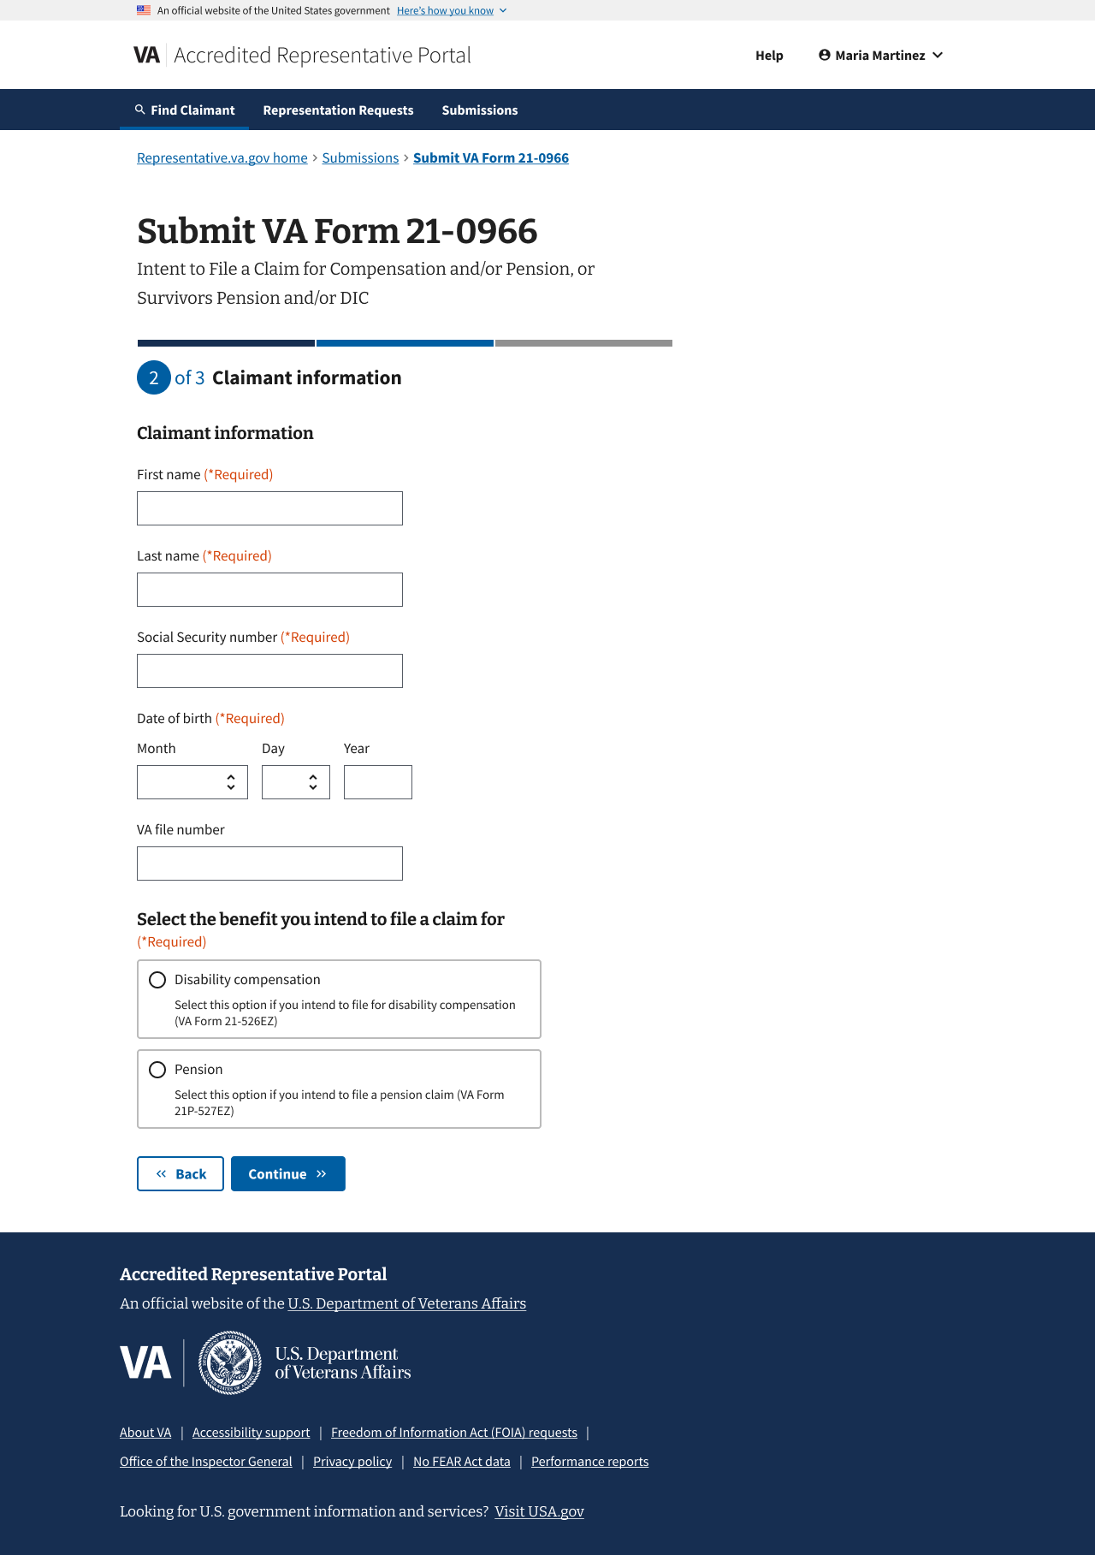

Step 2b: Claimant and Veteran information
If the representative selected “The claimant is a survivor or a dependent of the Veteran” on the previous page, they will need to enter the claimant and Veteran information on this page. They’ll also need to select which benefit they intend to file a claim for.

All information except the VA file number is required to continue.

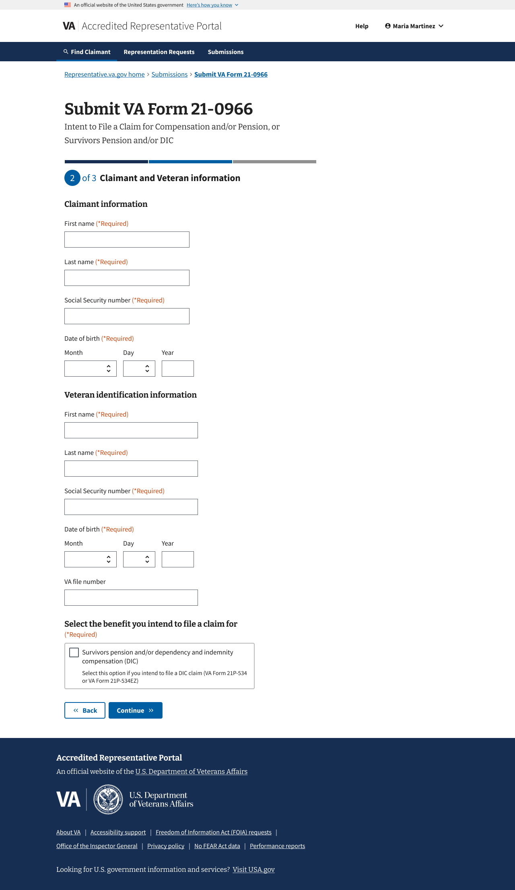

System will verify representation and check for intent to file
When the representative selects “Continue” on the previous Claimant information page, the system will verify that the representative or the Veterans Service Organization they’re accredited with represents the claimant. It will also check whether the claimant already has an intent to file.

The representative will not be allowed to continue the submission if:

- the representative does not represent the claimant, or
- the claimant already has an intent to file, or
- the system cannot verify if the claimant already has an intent to file

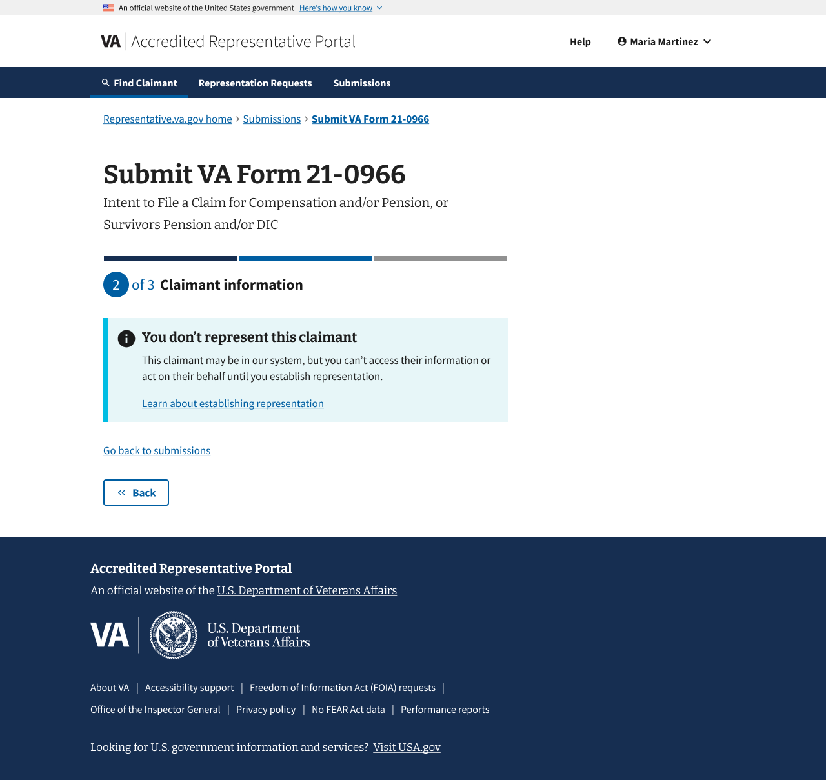

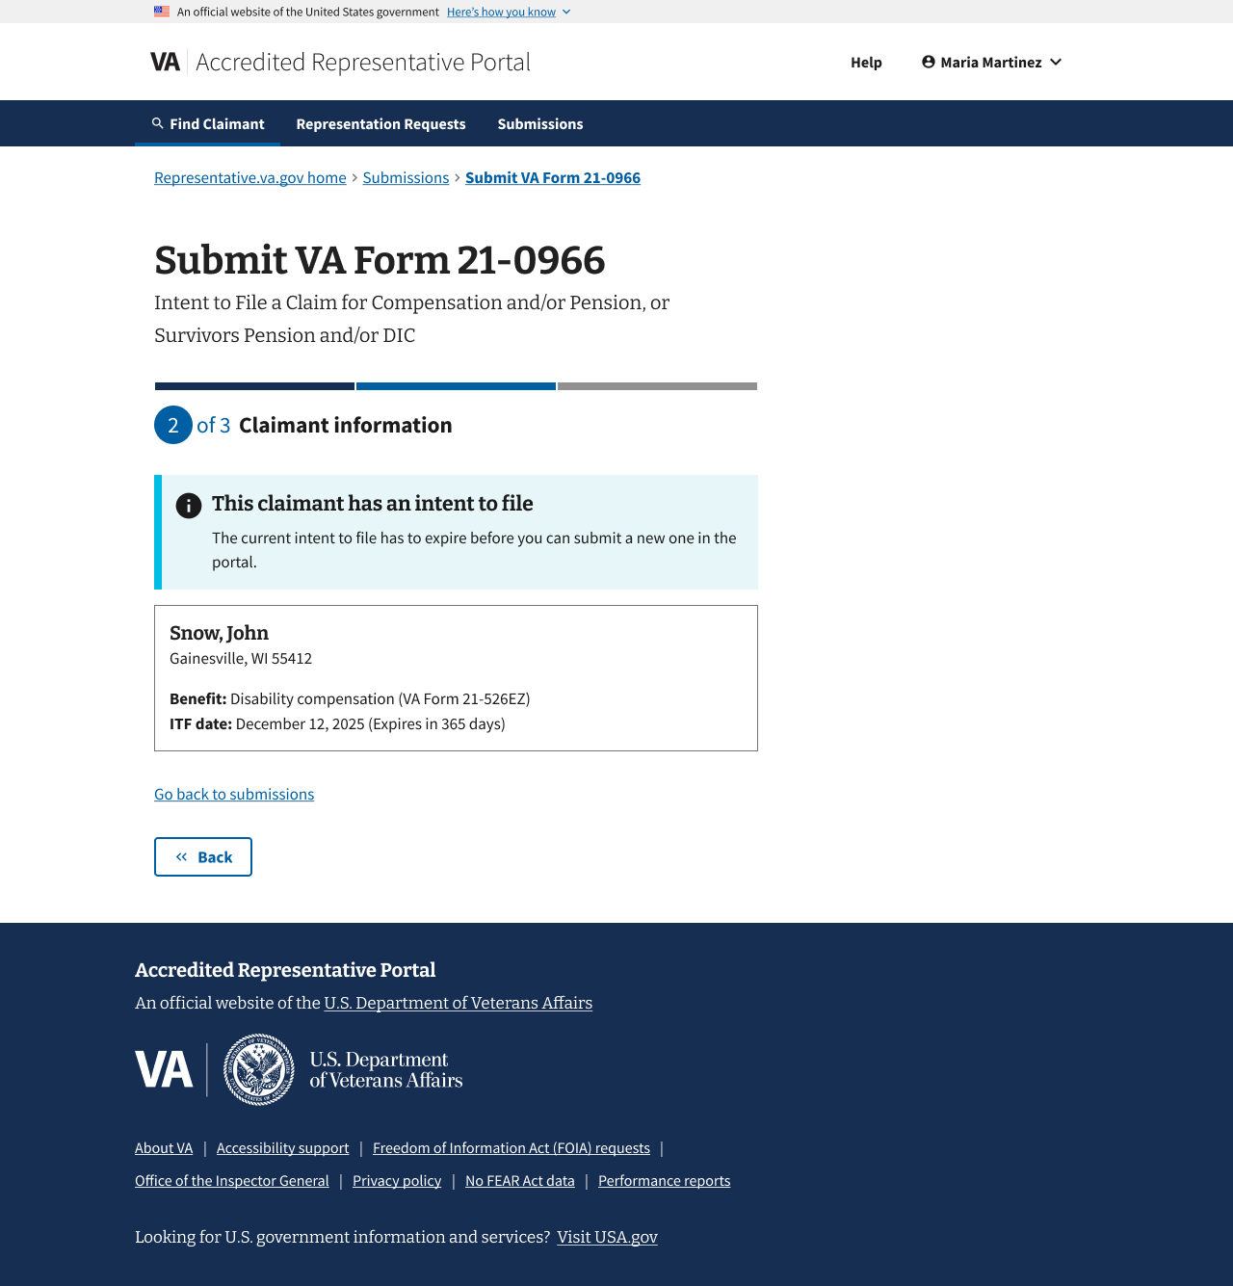

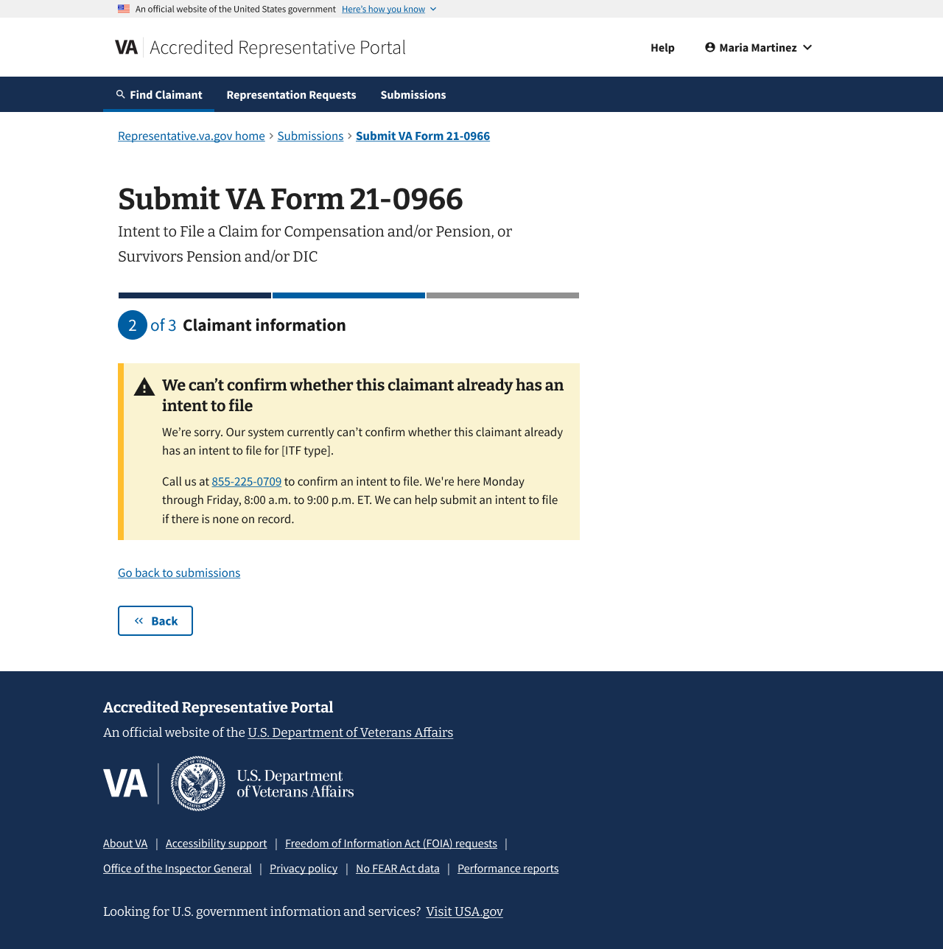

If the system can verify that the representative does represent the claimant, and there is no intent to file on record, they will continue the submission with Step 3: Review and submit.

Step 3: Review and submit
The representative can review the information on this page. They can click on Expand all to view all the information added from the previous steps. To collapse a specific section, they can click on the “–” on the right side of the collapsible section.

To edit information, the representative can click on the Edit button on the right of the section heading. Once the representative has finished reviewing and making any necessary changes, they can click "Submit" at the bottom of the page.

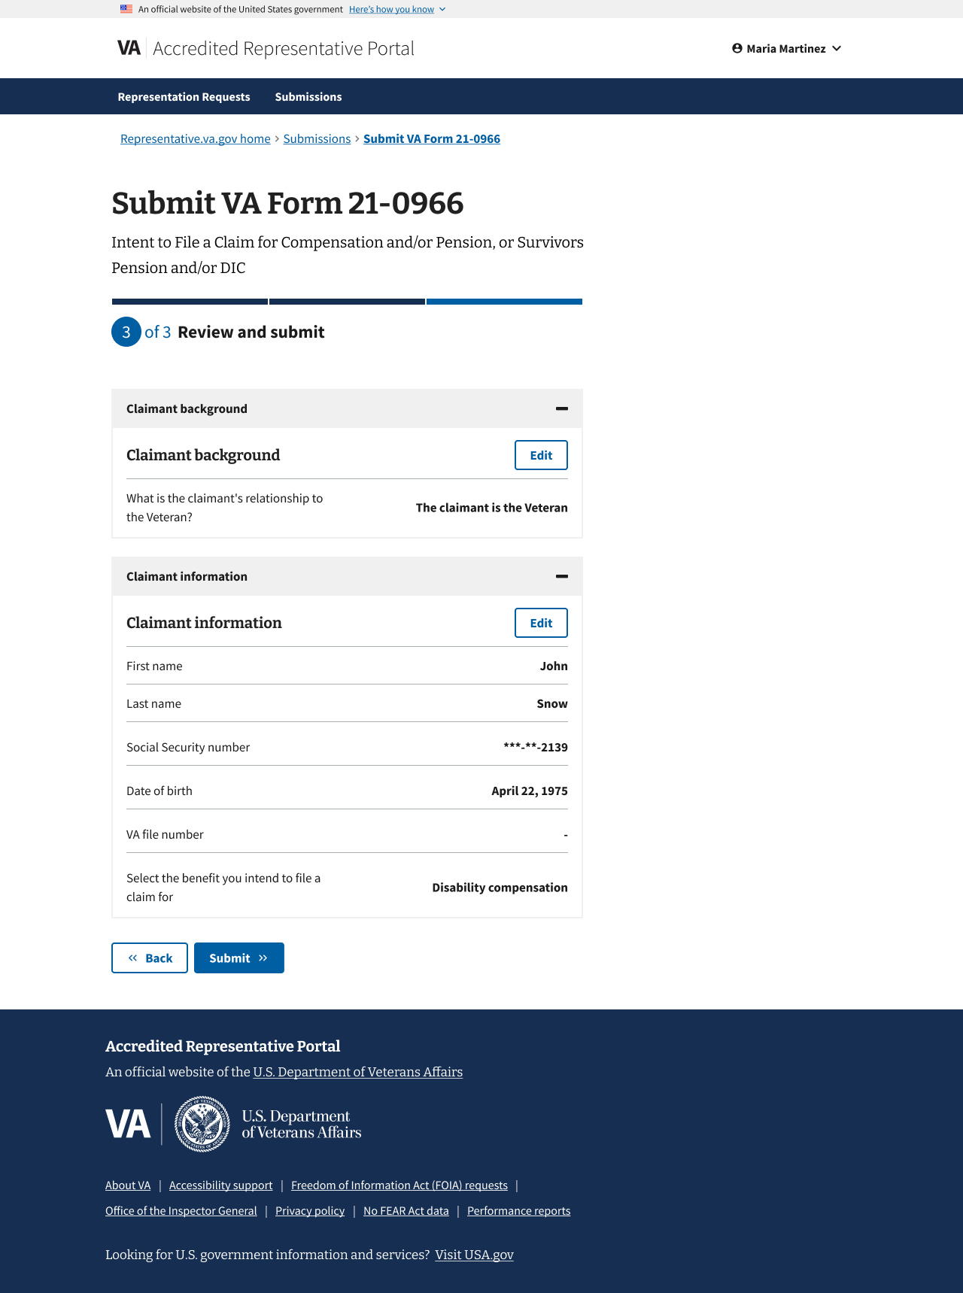

Confirmation
After submitting the form, there will be confirmation that the intent to file was recorded, and an overview of the recorded information.

The page will inform representatives of what to expect next. Representatives can review all their recent claim submissions by clicking Go back to submissions.

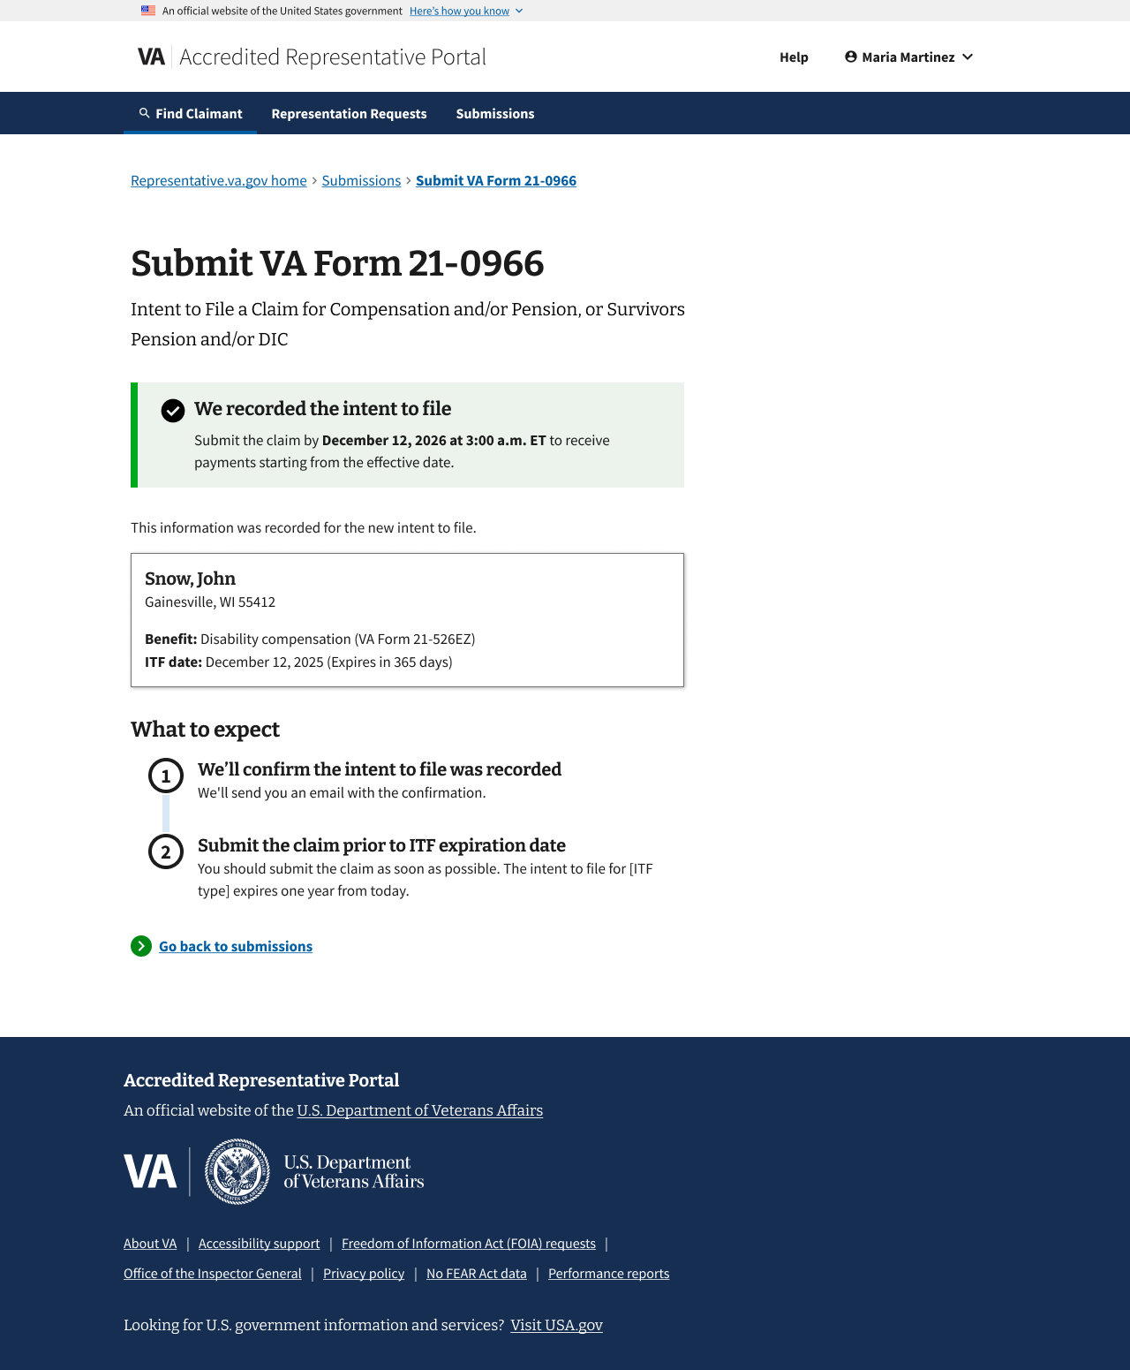

VA Form 21-526ez

From the Submissions page, the representative can click on "Upload" and submit the VA Form 21-526ez.
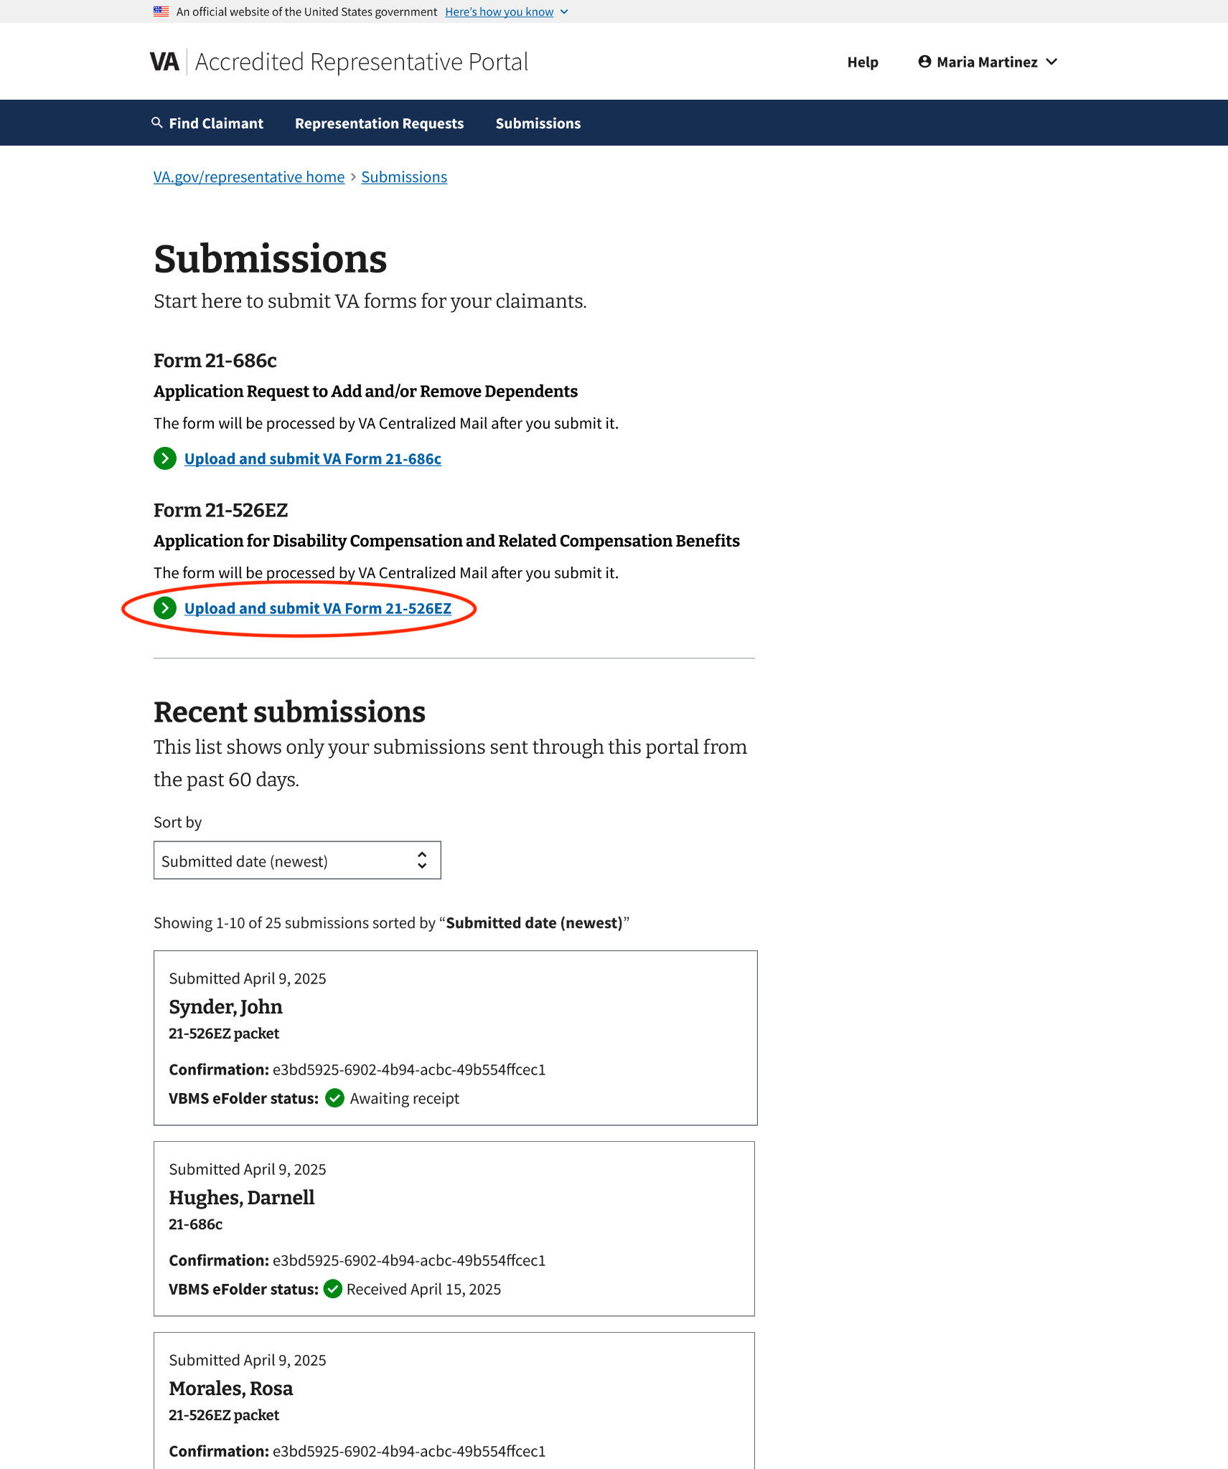

Introduction page
The VA Form 21-526ez introduction page provides instructions on how to submit a claim for disability or other compensation benefits. It provides clear steps on how to submit the form, along with a link to download the latest version of the form.

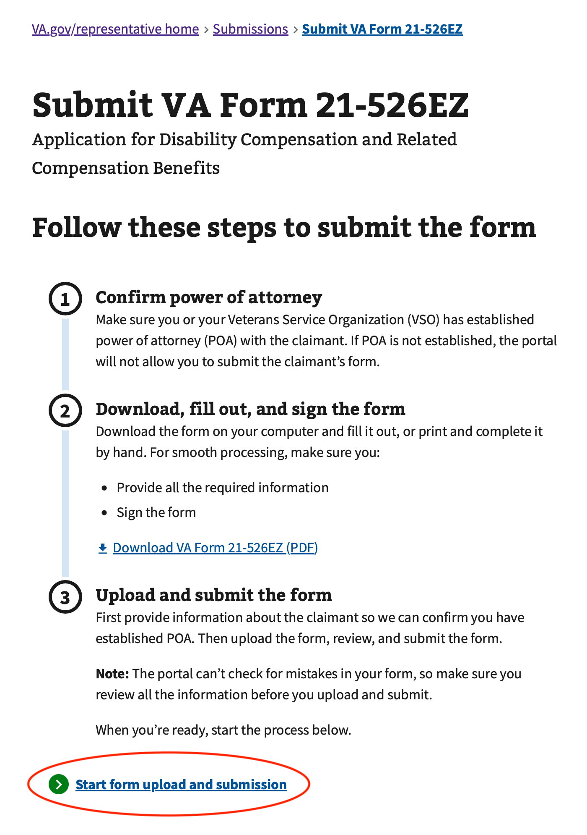
To initiate the process, the representative can click “Start form upload and submission.”

Step 1: Claimant information
The representative will need to enter the Veteran's information on this page. All information except the VA file number is required to continue.

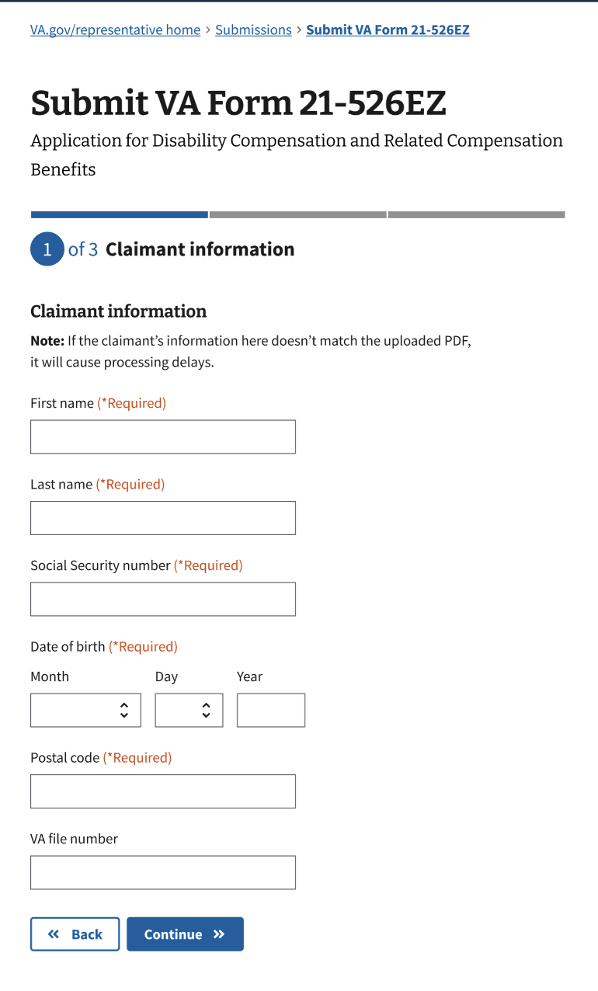
Step 2: Upload files
The representative will upload a completed VA Form 526ez (required) and any supporting evidence (optional) they want to include.
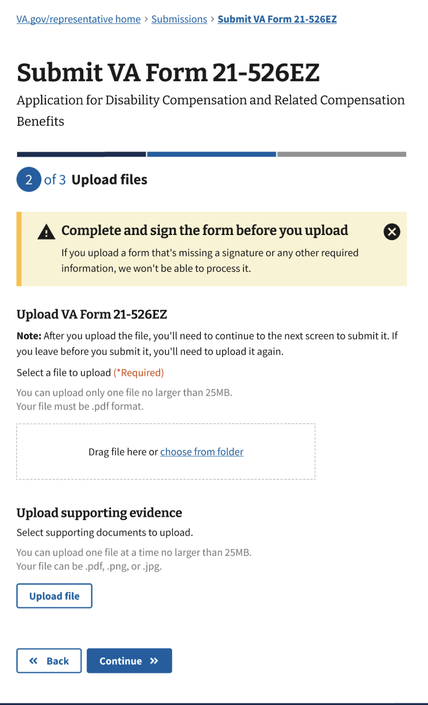

Uploading VA Form 21-526ez (required)
The representative will upload the completed VA Form 21-526ez form in the first section. They must verify the form is completed and signed before uploading; otherwise, the submission will not be processed.

They can drag and drop the form within the draggable area or choose the form from a folder. The form cannot exceed 25MB in size and must be in PDF format.

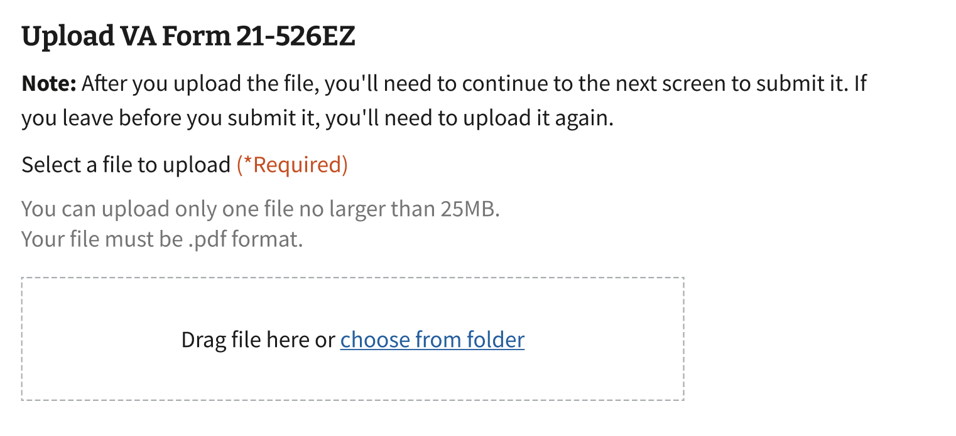
To change the form they uploaded, the representative can choose to Change File. To delete the form, they can select Delete.

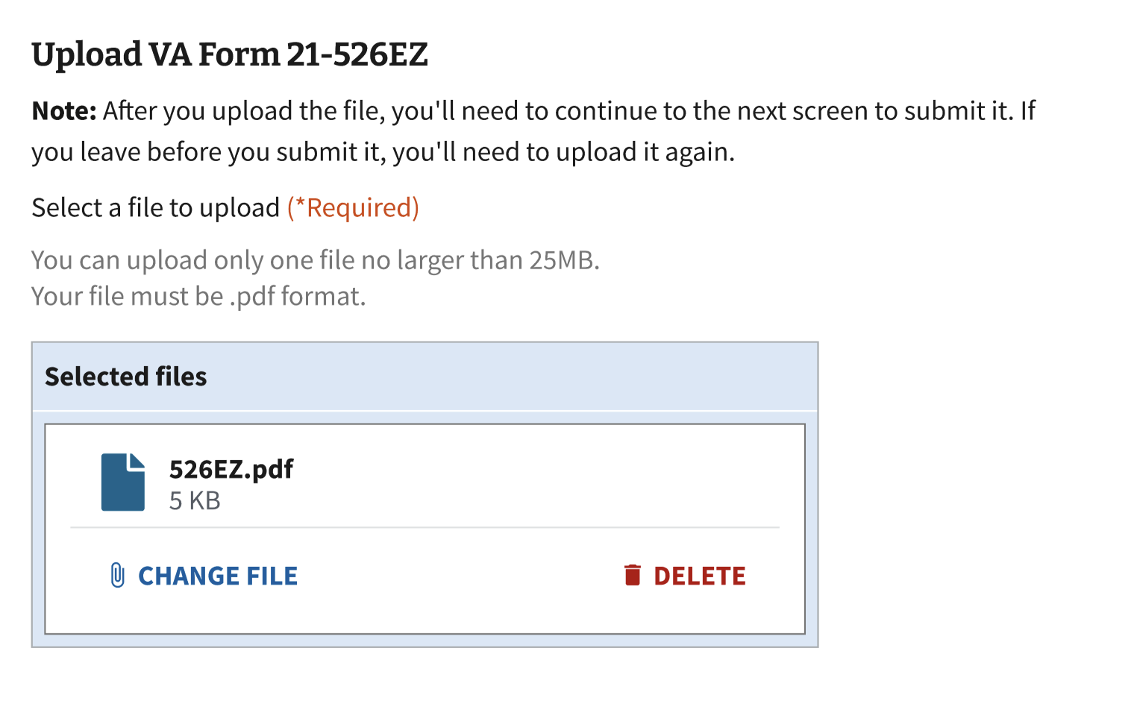

Upload supporting evidence (optional)
The representative will upload any supporting evidence in the second section. Only one file can be selected for upload at a time. More than one file can be added as supporting evidence.

They click on the "Upload File" button and select a file from a folder. Files cannot exceed 100MB in size and must be in PDF, PNG, or JPG format.
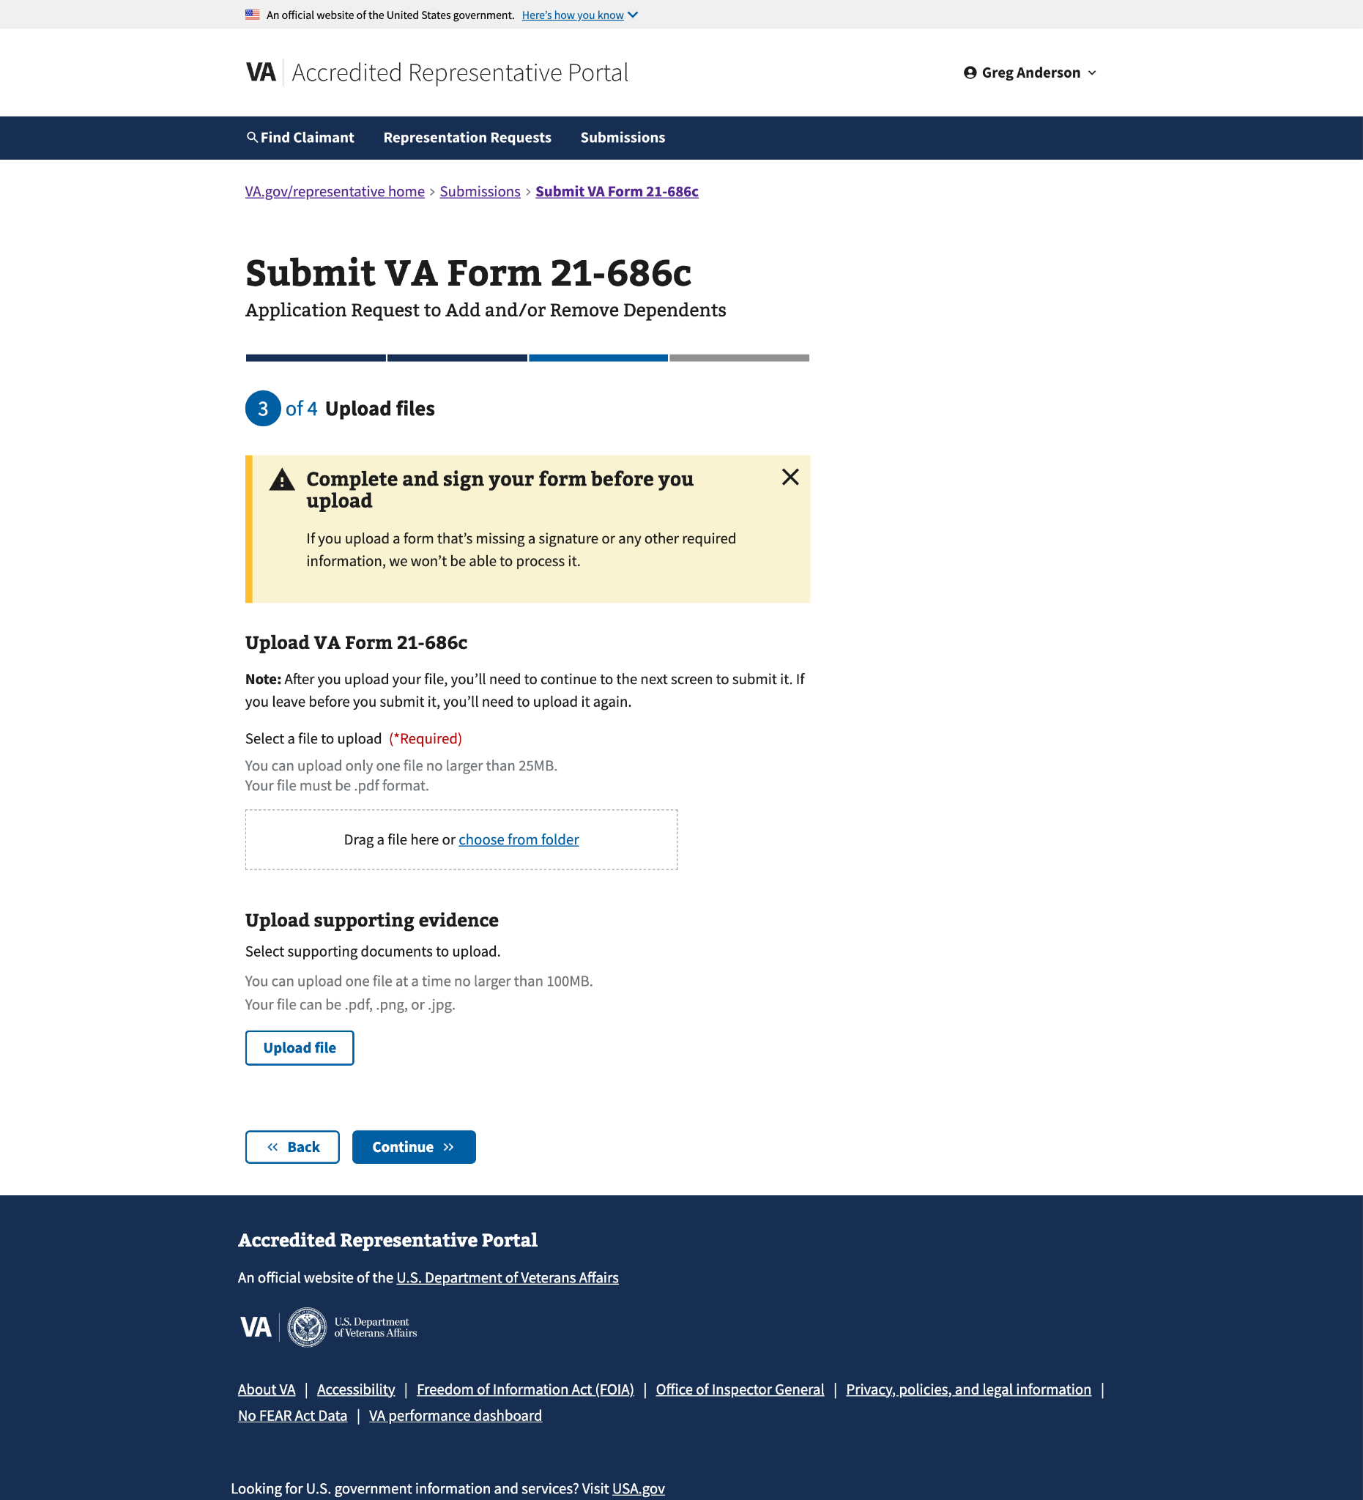
To delete a file uploaded, the representative can choose Delete file. To upload another file, they can select Upload another file.
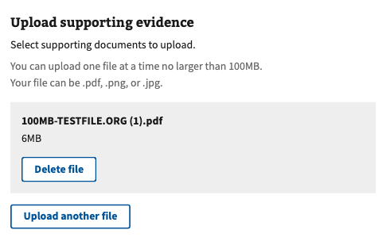
Once the representative has uploaded all the supporting evidence, they can click Continue at the bottom of the page.

Step 3: Review and submit
The representative can review the information entered and the uploaded file(s) on this page. They can click on Expand all to view all the information added from the previous steps. To collapse a specific section, they can click on the “–” on the right side of the collapsible section.

To edit information, the representative can click on the Edit button on the right of the section heading. Once the representative has finished reviewing and making any necessary changes, they can click "Submit" at the bottom of the page.

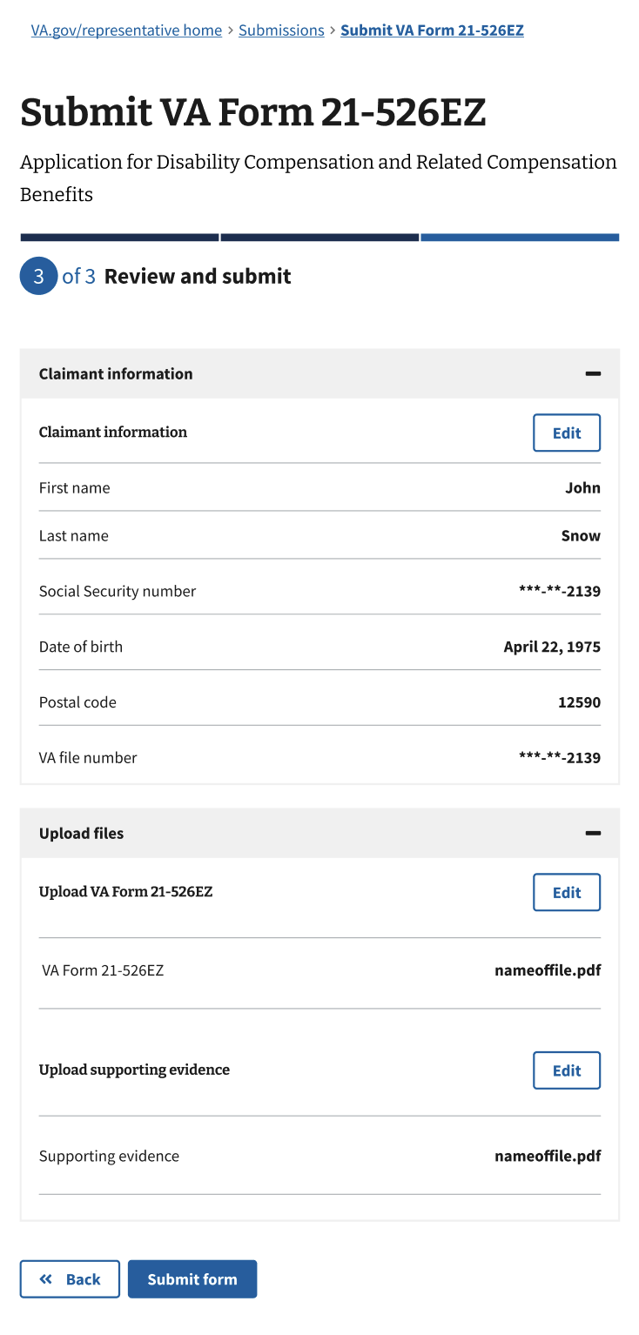
Once the representative has finished reviewing and making any necessary changes, they can click "Submit form" at the bottom of the page.

Confirmation
After submitting the form, the representative will receive a message letting them know the intent to file has been recorded. The confirmation number can be used to check the status of a claim. Representatives will also receive an email confirmation with the number included. The email will not have specific claimant details to protect their PII.

The confirmation page will inform you of what to expect next after submission. Representatives can review all their recent claim submissions by clicking Review submissions history.

VA Form 21-686c

From the Submissions page, the representative can click on "Upload" and submit the VA Form 21-686c.
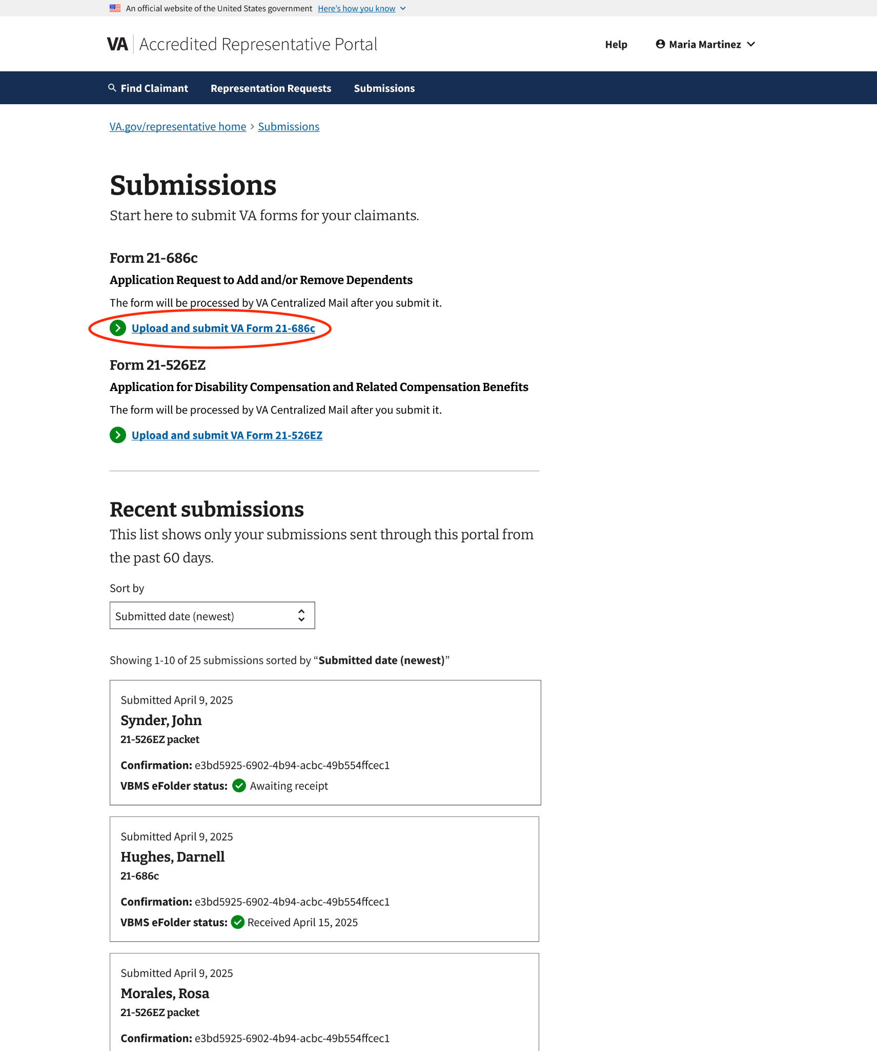

Introduction page
The VA Form 21-686c introduction page provides instructions on how to submit a claim to add and/or remove a dependent for benefits. It provides clear steps on how to submit the form, along with a link to download the latest version of the form.

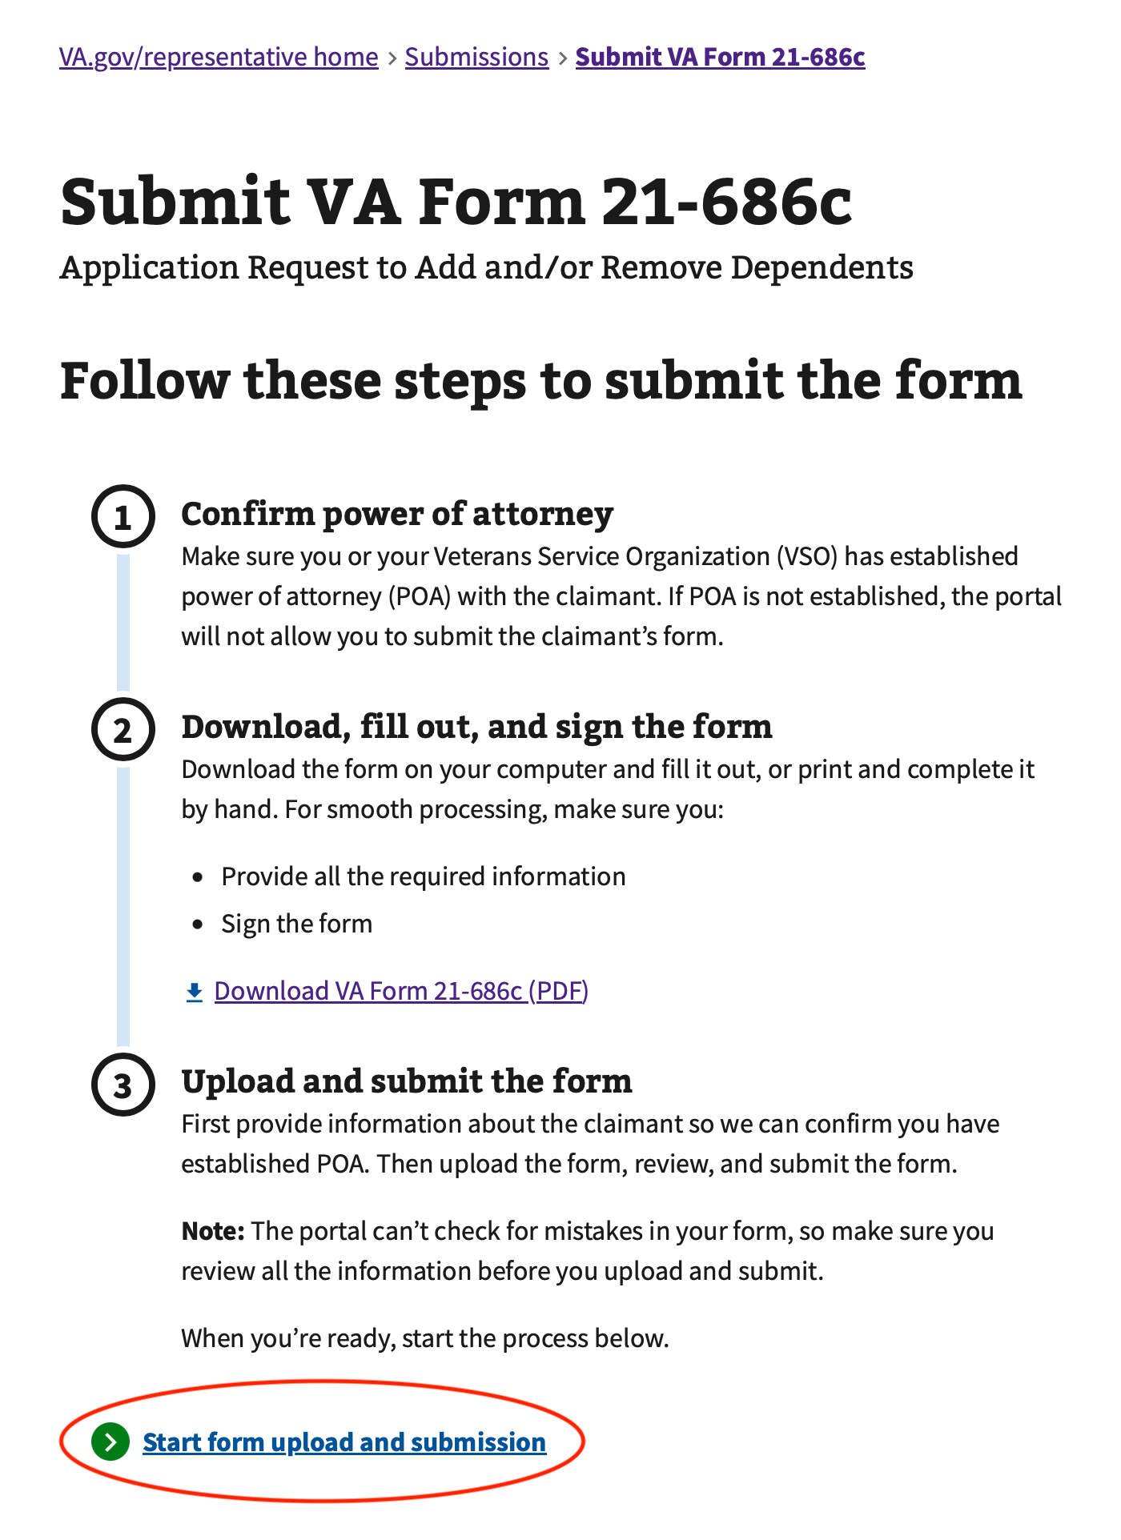
To initiate the process, the representative can click “Start form upload and submission.”

Step 1: Claimant background
This representative must select if the claimant is the Veteran, or the survivor or dependent of the Veteran. This information is required to continue.
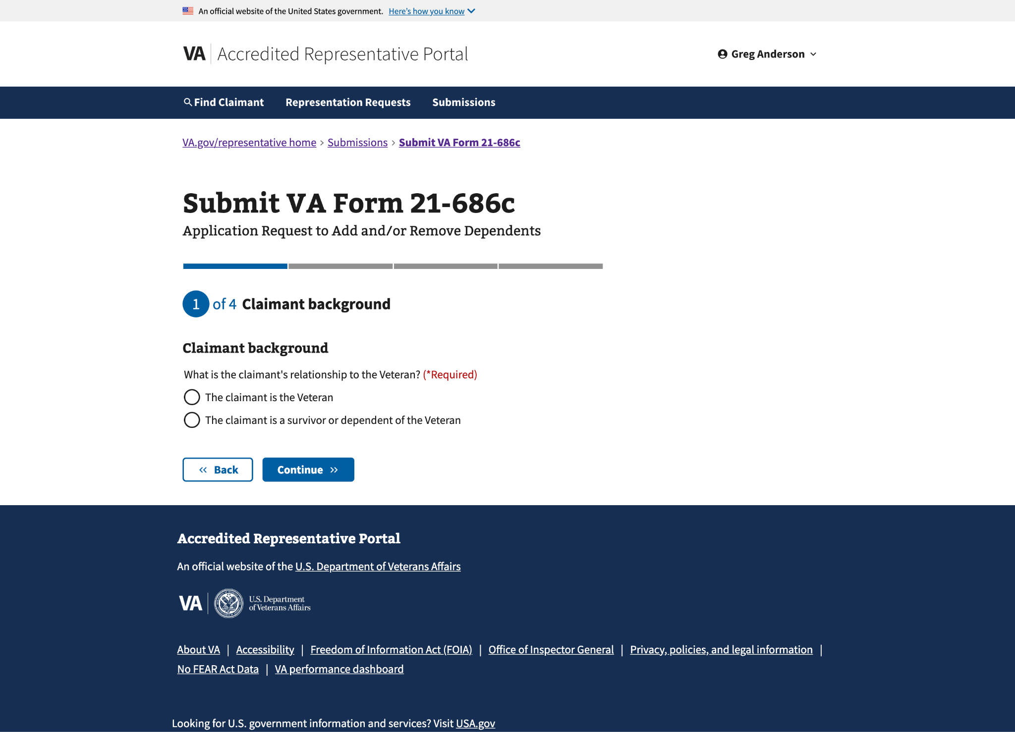

Step 2a: Claimant information
If the representative selected “The claimant is the Veteran” on the previous page, they will need to enter the Veteran's information on this page. All information except the VA file number is required to continue.
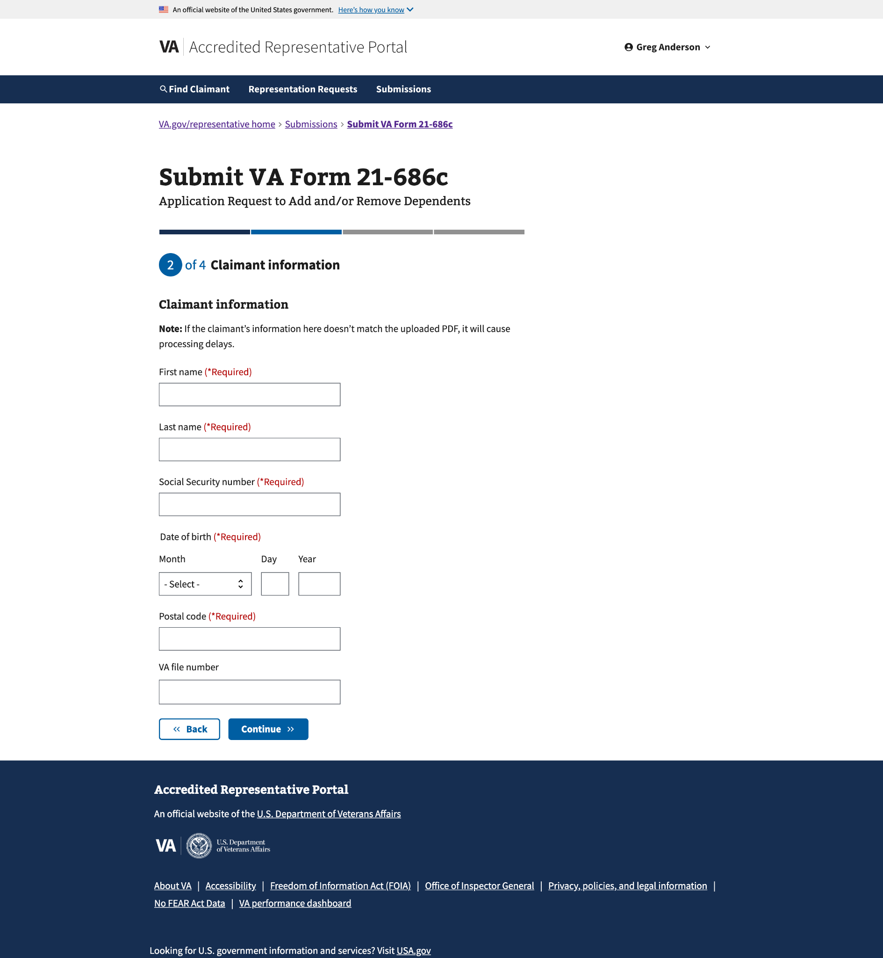

Step 2b: Claimant and Veteran information
Suppose the representative selected “The claimant is a survivor or a dependent of the Veteran” on the previous page. In that case, they will need to enter the claimant and Veteran information on this page. All information except the VA file number is required to continue.
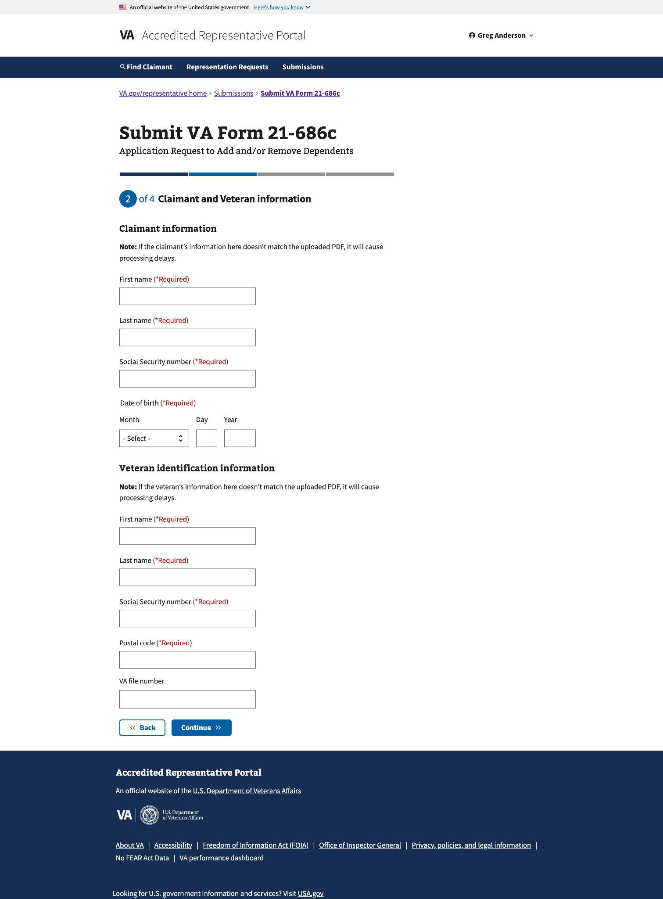

Step 3: Upload files
The representative will upload a completed VA Form 21-686c PDF (required) and any supporting evidence (optional) they want to include.


Uploading VA form 21-686c (required)
The representative will upload the completed VA Form 21-686c form in the first section. They must verify the form is completed and signed before uploading; otherwise, the submission will not be processed.
They can drag and drop the form within the draggable area or choose the form from a folder. The form cannot exceed 25MB in size and must be in PDF format.

To change the form they uploaded, the representative can choose to Change File. To delete the form, they can select Delete.
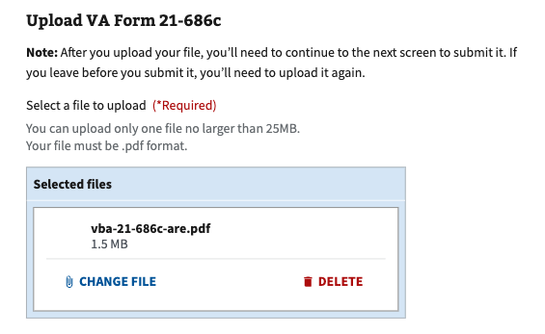

Upload supporting evidence (optional)
The representative will upload any supporting evidence in the second section. Only one file can be selected for upload at a time. More than one file can be added as supporting evidence.

They click on the "Upload File" button and select a file from a folder. Files cannot exceed 100MB in size and must be in PDF, PNG, or JPG format.

To delete a file uploaded, the representative can choose Delete file. To upload another file, they can select Upload another file.

Once the representative has uploaded all the supporting evidence, they can click Continue at the bottom of the page.

Step 4: Review and submit
The representative can review the information entered and the uploaded file(s) on this page. They can click on Expand all to view all the information added from the previous steps. To collapse a specific section, they can click on the “–” on the right side of the collapsible section.

To edit information, the representative can click on the Edit button on the right of the section heading. Once the representative has finished reviewing and making any necessary changes, they can click "Submit" at the bottom of the page.

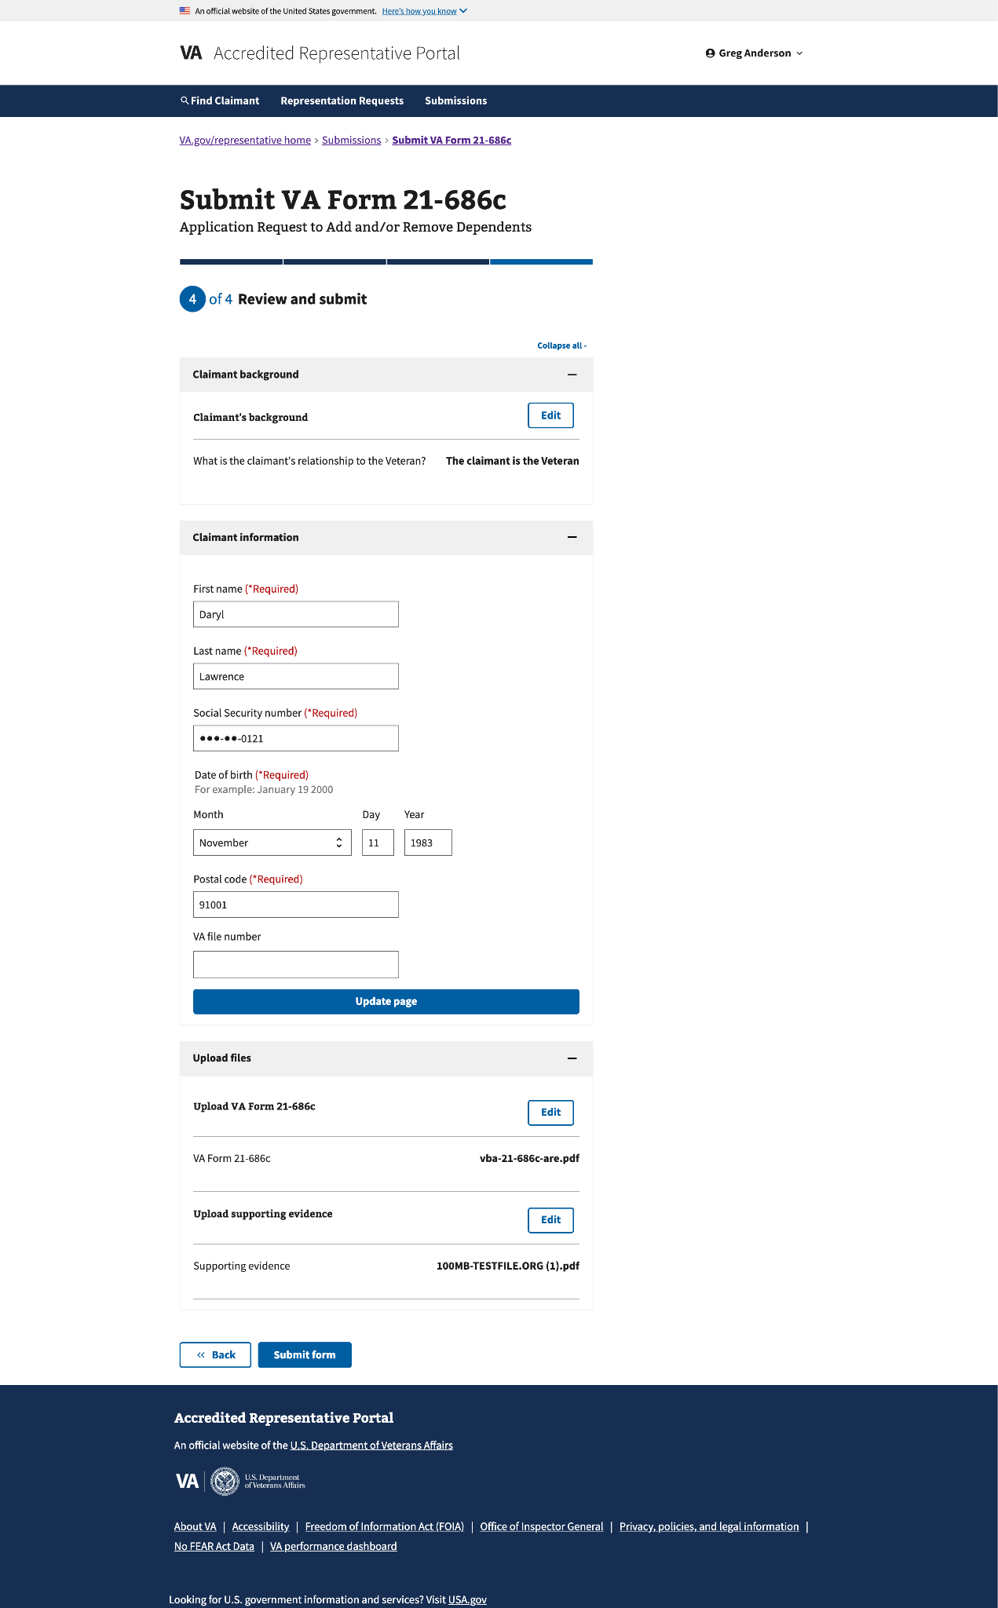

Confirmation
After submitting the form, the representative will receive a confirmation number. The confirmation number can be used to check the status of a claim. Representatives will also receive an email confirmation with the number included. The email will not have specific claimant details to protect their PII.

The confirmation page will inform you of what to expect next after submission. Representatives can review all their recent claim submissions by clicking Review Submission History.

Major Issues and Error Messages

User access issues

Login.gov issues
If the representative is having trouble creating, managing, or signing in with their Login.gov account, they can visit the Login.gov Help resources for guidance.

ID.me issues
If the representative is having trouble creating, managing, or signing in with their ID.me account, they can visit the ID.me Help Center.

Accreditation not found
When a user signs in to the portal and the current accreditation cannot be verified, they will be taken to an unauthorized dashboard. The dashboard displays an alert letting them know their accreditation couldn’t be verified. There are also links to help troubleshoot login issues and learn about the accreditation application process.

Troubleshooting unverified accreditation
If the user is accredited but the portal isn’t able to verify their accreditation, ask the representative the following questions to help troubleshoot potential issues:

Reference: OGC Accreditation Search

- Is your email address on file with OGC correct or missing?
  - If not, update your OGC contact information.
    - For accredited representatives, contact your certifying official to update your information with OGC. They can email AccreditationMailbox@va.gov.
    - For attorneys and claims agents, contact OGC directly with your updated info: AccreditationMailbox@va.gov
- Is the email you have on file with OGC associated with your Login.gov or ID.me account?
  - If not, add it to your account:
    - For Login.gov, go to https://secure.login.gov/account and Email addresses
      - Add email address associated with OGC
      - You’ll receive an email to confirm
      - Go back to your Login.gov and verify that your new email address has been added
    - For ID.me, go to https://account.id.me/overview
      - Go to Manage your profile
      - Add email address associated with OGC
- Is the email you have on file with OGC unique to you?
  - If not, you will not be able to use that shared email address to sign in to the portal. You will need to update your OGC contact information to use an email that is unique to you, and then associate that email with your Login.gov or ID.me account.

Additional user access troubleshooting

- Signing in to the portal (in this document)
- Help page > Creating your account (in the portal)

If the representative has tried all troubleshooting steps and the issue still cannot be resolved, you should escalate the problem to the portal team at RepresentativePortalHelp@va.gov.


Representation request issues

Request failed to process
Typically, a representation request will process within 1-2 minutes. Occasionally, there may be a problem processing the request. When this happens, representatives and claimants will be notified that the request failed to process.

In the portal, messages will be displayed on the request card and request details page, notifying the representative that the request cannot be processed.
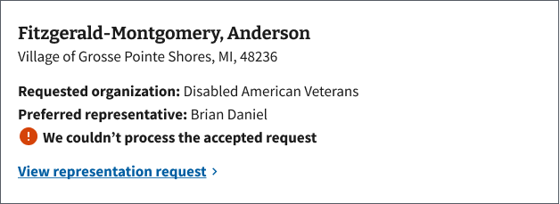
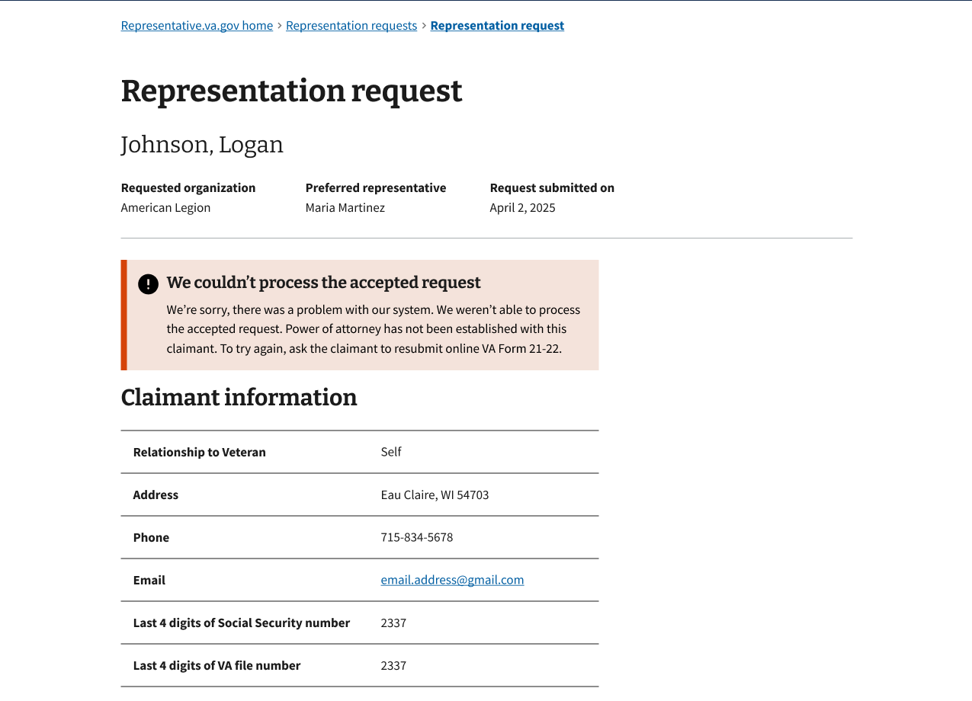
An email will be sent to the representative and the Veteran letting them know the request couldn’t be processed.

Note: Email notifications will be sent to the email that the representative has on file with OGC.

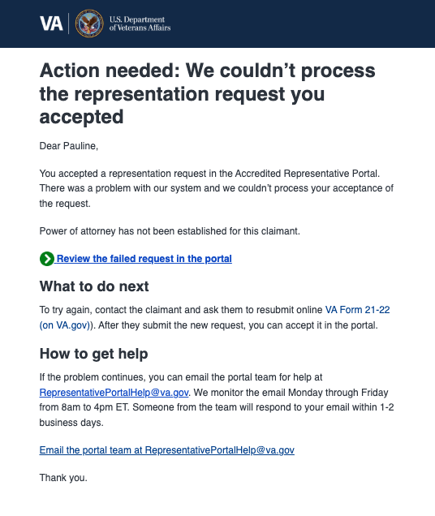
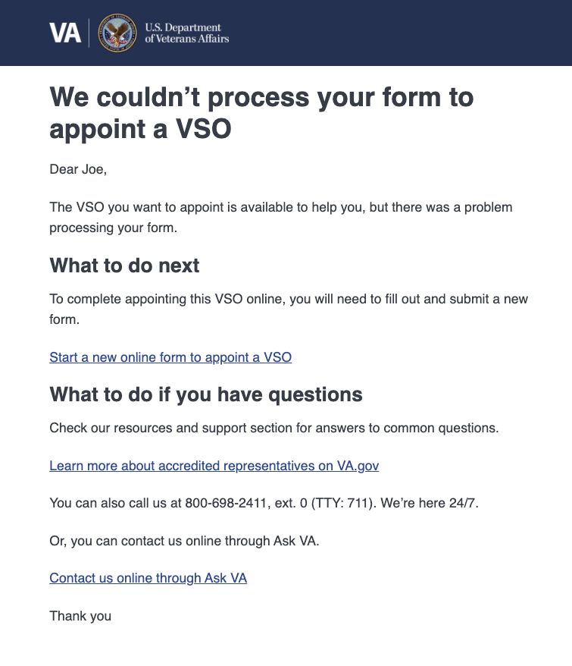

Resolving a failed request
When a request fails to process, the Veteran will need to submit a new online VA Form 21-22 that will populate in the portal for the representative to accept.

Submission Issues

Upload errors
While a PDF form is uploading, the representative may receive an error message stating Upload a completed VA Form [form-number]. This error will clear once the form has finished uploading.
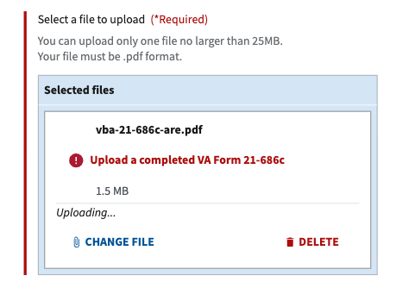

If the representative attempts to proceed without uploading a required form, or before a require form has completed uploading, they’ll receive an error message stating Upload a completed VA Form [form-number]. Once the form is successfully uploaded, the error will clear, and they’ll be able to continue the submission process.
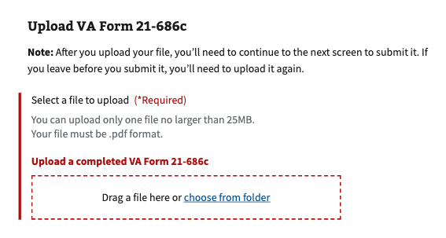
If the representative tries to upload a file larger than 100MB, they’ll receive an error message letting them know their Document exceeds the file size limit. They’ll need to upload a new file that is within the file size limit before they can continue.
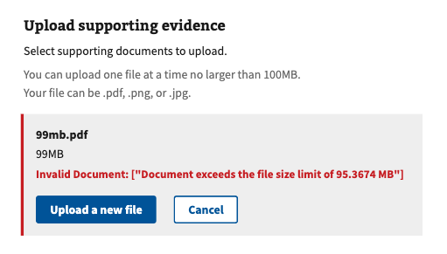

Losing unsaved work
The submissions workflow does not save the representative’s work as they go. If the representative were to refresh a page while in the middle of a form submission, they would lose all of the information they had entered so far. To prevent accidental loss of the representative’s work, if they refresh a submission page, they’ll receive a pop-up message letting them know their changes may not be saved.

The representative can choose to Reload the site, which will clear all of the information they’ve entered so far, or Cancel and continue working on submitting the form.
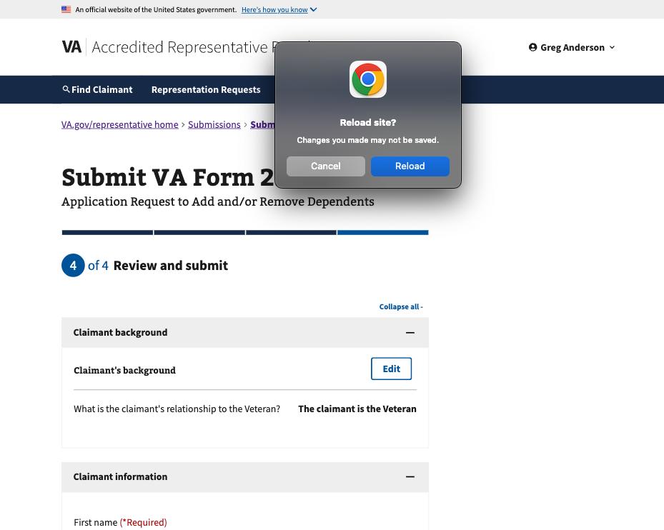

The form can’t be submitted
When a submission fails for an unknown reason, one of two errors will display. The representative will be instructed to try submitting the form again later, or to call us for help submitting the form.
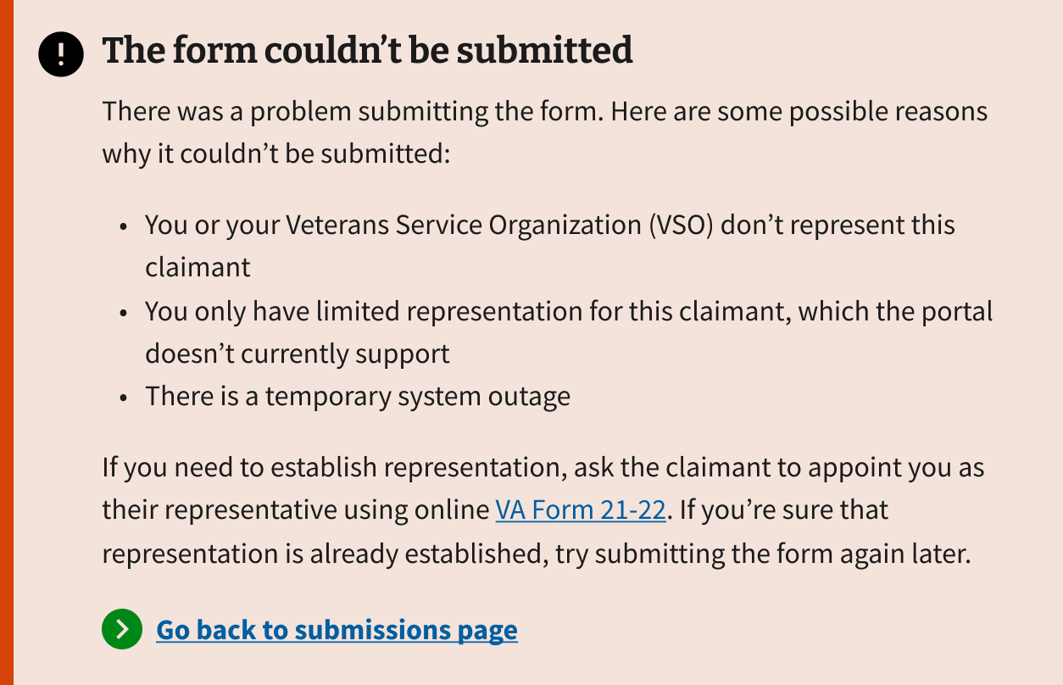
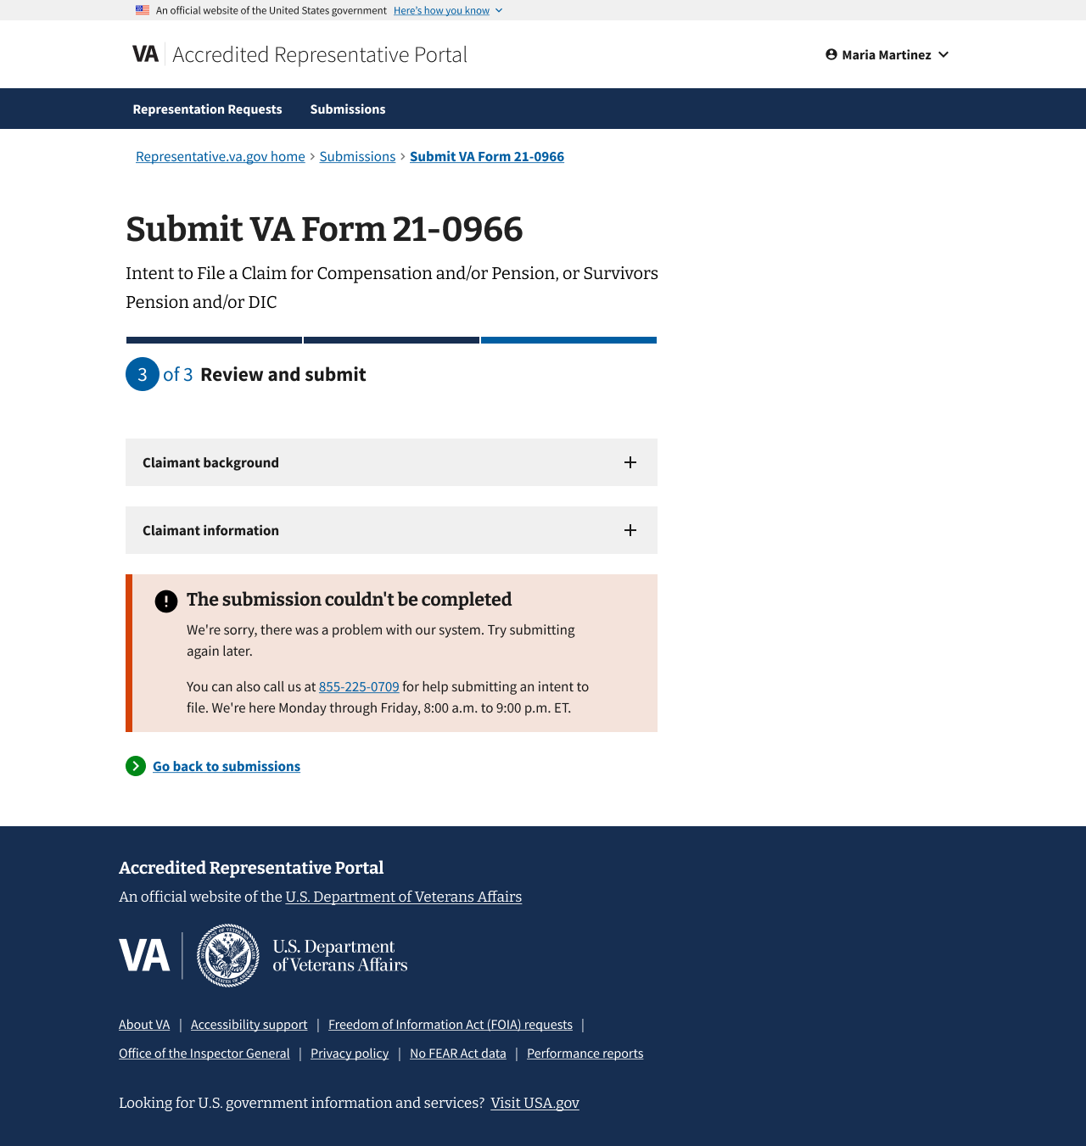

When a submission fails due to high system traffic, an error message will be displayed, notifying the representative. The representative will be instructed to try submitting the form again later.
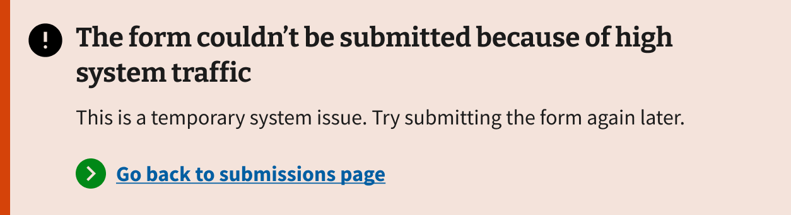

Submission failed to process
If an error occurs while processing a submitted form, an email will be sent to the representative to notify them of the issue. The email provides the confirmation number for the failed submission, allowing the representative to look it up in the portal and review the full submission details.

The representative should call the VA benefits hotline at 800-827-1000 for help resolving the processing error.
